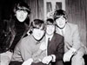
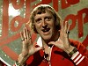
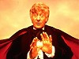
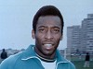
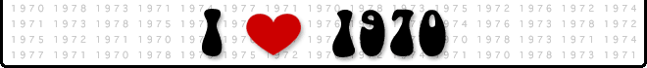

Pele wins the World Cup Jon Pertwee – Dr. Who Jimmy Saville – TOTP the Beatles split

So a new decade began, ‘The 70’s’. Trouble was I was still only 5 years old, so why would I care if the Beatles had split up, Brazil had won the World Cup, and Jon Pertwee was the new Dr. Who. Actually I did care about Dr Who, Saturday nights 5.15pm, after Final Score and the Pools check, it was Dr Who time. I’d watch it with my brothers and I don’t mind telling you that I was shit scared. There were the Daleks, the Cybermen, the Sea Devils, but the one that really got me was the Master. He was a really nasty piece of work, who gave me the creeps,
You may remember me telling you that Auntie Vi and Uncle Doug had moved into a massive house in Westbury on Trym (Bristol). Well I don’t know if they’d realised that Doug’s mother, Olive Smith, had planned to move into the building and take over the entire first floor. Well she had! Vi had cottoned on to Olive’s game, make out that she couldn’t cope on her own and Vi & Doug would do everything for her. Olive already had Mum and Vi out looking at Indian carpets, in Bristol. What would be next? There’d be some clashes and you didn’t want to be in the vicinity when it all kicked off.
It might’ve looked like I was getting my bedroom decorated, but was all to disguise the fact that an airing cupboard had been built in my bedroom. These builder blokes came in and just halved the size of my room. I didn’t know where I was supposed to put all my toys. Hey, I was only a kid, what say did I have in anything? None.
I went on a school trip to Bristol Zoo. I used to think Bristol Zoo was the greatest place on earth. They had the White Tigers, Camels, Polar Bears, Penguins and the animal viewing was brilliant. Also, one of my favourite programmes was filmed at the zoo, ‘Animal Magic’ with Johnny Morris. However it didn’t prepare me for our trip to Longleat. This was a massive Safari Park, where you drove through the animal enclosures in your car. In the Monkey enclosure, they were all over your car trying to steal whatever they could get their hands on. They managed to get some rubber bits off our bonnet. It was so funny!
Quite often, dad would take us all swimming at Shirehampton Baths. I say swimming, but I couldn’t actually swim. I had to wear these poxy inflatable arm bands. It was so embarrassing, especially when Fiona passed her stage 2 swimming test. Charlie and Dave just swam up and down like fish. At least Fiona helped me learn to ride my bike. However I also needed artificial assistance with this, in the shape of stabilisers. It could be very frustrating, having older brothers and sisters.

Apollo 13 was launched on 11th April 1970 but not long after take-off there was an explosion. They had to abandon the planned Moon landing after rupture of a service module oxygen tank. Dad loved that entire Space thing and followed the story on TV for days. They landed home safely after a very tense 3 days drifting in space. I reckoned they could make this into a film one day.
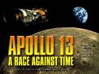
Houston, we've had a problem here."
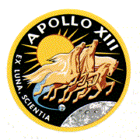
We had some drama on our own doorstep. Someone was murdered on Shirehampton Golf Course and the police called at our house to ask Dave some questions about it. Surely they couldn’t have suspected my brother of being a murderer; he was only 14 years old for god’s sake. After a bit of Police brutality they decided to let Dave go, but told him not to leave the country.
Have a guess where we went on holiday this year? I’ll tell you shall I, Bloody Scotland! Not only was it a foreign country, it was miles and miles away. I wondered how many times I could say “Are we there yet?” on the 72 hour, 2658 mile car journey. Anyway, we set off on July 31st. We dropped Jenny at the kennels, then drove on to Westmoreland and stayed in the Shap Wells Hotel. As I mentioned before, Dad could never just take us somewhere. We always had to stop off and visit one of his cronies. This time some bloke called Arthur Birchall took us on a guided tour of the M6 project. It’s bad enough being dragged round an Art Gallery or a Museum, but this was basically a road they were building. “Here’s a hole we dug earlier and here’s 3 million cones that we’ve put on the road for no good reason whatsoever”. We eventually arrived at our destination (6 berth caravan in Dalmally, Argyllshire) a good 2 days after setting off.
On the first day of our holiday we were out walking and came across what Dad described as, Nomads living in a Bedouin tent. Come on Dad, I might’ve only been 6 years old, but Bedouin Nomads? This was Scotland, not the Sahara Desert. Bill & Nicole, and Bill’s brother Simon, anyone could see that they were just ‘Soap Dodging Hippies’. Mind you it turned out that they’d got some Ponies and offered to let us have a ride. What was I saying? “Nomads rule”. Luckily I was dressed for the occasion. I was wearing comfortable brown sandals, fetching avocado leggings with matching polo shirt. I easily outdid Fiona in the fashion stakes. She blended in with the scenery beautifully, with her orange jumper and turquoise trousers. Charlie and David also had a go on the ponies, but looked a bit big for the poor little nags.

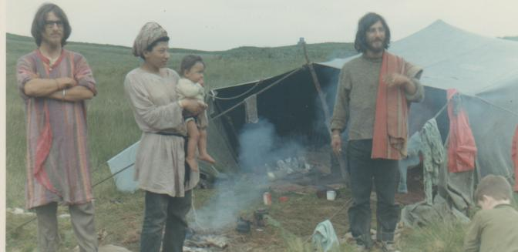
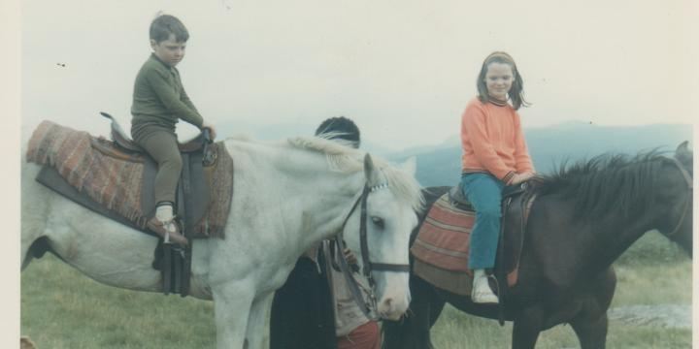
Ride’em Cowboy. Bedouin Nomads?

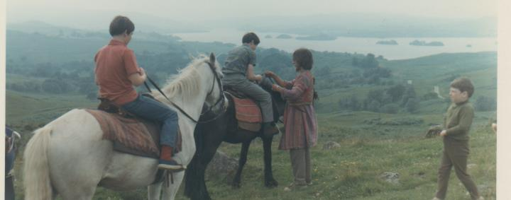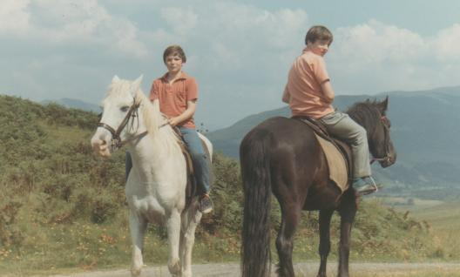
Nice Basin Cut! Lone Ranger & Tonto

We actually did quite well for holidays. In the May Half term we went on holiday to Torquay, staying at ‘Fawlty Towers’. Well we didn’t really, it was called Hotel Roseland. On our second day we went to Paignton Beach, and then in the evening went to see ‘Oliver’ at Paignton Cinema. The next day we went to the model village at Babbacombe and spent the afternoon at Tore Abbey sands. I cried for help in the hotel, when I couldn’t find a vacant w.c. Really I was just trying to blame someone for me pissing in my pants. We certainly used to cram it all in on our holidays. The next day we went on the ‘Western Lady’ ferry to Brixham. While there a photographer took a photo of me holding a monkey and Charlie with a parrot on his shoulder. A couple of days later it was another boat trip. This one was on the ‘Conway Castle’ from Dartmouth to Totnes and back. While we were out, I was mucking about in the bushes and found a portable tape recorder. Not only that, it contained a ‘Beatles’ cassette. For you younger readers, I must explain that a cassette recorder is something that we used to listen to music on, in the olden days. Let me put it in context, it’s like finding an i-pod with a thousand songs already on it. Charlie told me that the legal age limit for owning a cassette recorder was 7 years old. He said that as I was only 6, the police would take me away and lock me up. So he kindly offered to take ownership of the cassette recorder, to save me getting into trouble. What a wonderful gesture. I now realise that I was tricked!
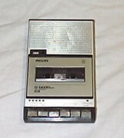

Tape Recorder c1970

The S.S. Great Britain
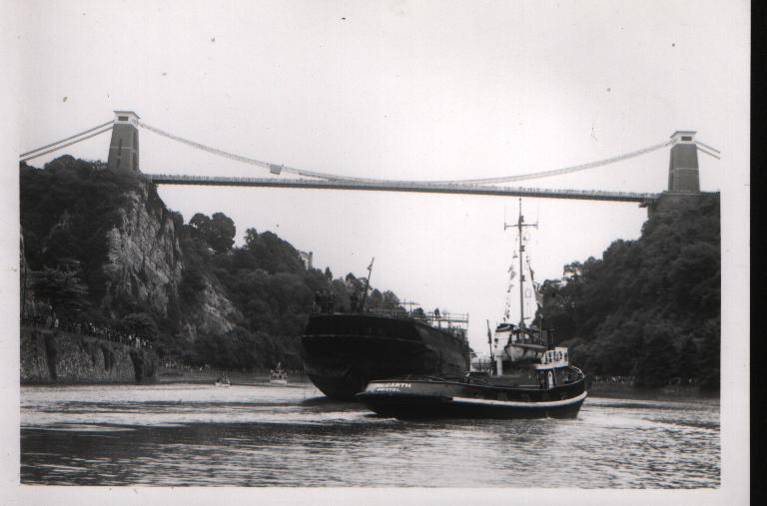
Designed by Isambard Kingdom Brunel, the ship was built in 1843 at the Great Western Dockyard in Bristol, under the supervision of Brunel and his colleagues at the Great Western Steamship Company & Thomas Guppy, Christopher Claxton and William Patterson. From the outset, the S.S. Great Britain was unique. Widely regarded as one of Brunel's finest works, she was built to serve the burgeoning transatlantic passenger trade. On 26 July 1845, the ship undertook her maiden voyage to New York, a journey completed in an astounding 14 days. This achievement marked the beginning of a rich nautical history, and the S.S. Great Britain is now widely recognised as one of the technological forerunners of much modern shipping. She is also viewed by many as exemplifying the industry and inventiveness of the Victorian era, while symbolising the birth of international passenger travel and world communications
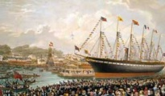
Maiden Voyage 26 July 1845 Final Voyage 5 July 1970

5th July 1970 - S.S. Great Britain completed her journey back to Bristol from the Falkland Islands, where she had been rusting away for many years. Fortunately for us, Dad’s work had the use of a boat called ‘Betty Brown’, which was moored in a place called Pill. We’d all got up early and went on the ‘Betty Brown’ to meet the Great Britain on her historic trip up the Avon. We followed her all the way to Cumberland Basin, under the Clifton Suspension Bridge (also designed by IKB), to the chorus of ships’ hooters. There were crowds of thousands, but we probably had the best seats in the house.

1970 was World Cup year again and England were defending their trophy in Mexico. I was too young to remember 1966 and to tell the truth I was still about 2 years away from discovering the joys of Association Football. Shame because it was a great World Cup which was won by Brazil, beating Italy 4 – 1 in the Final. The star of the World Cup was Edson Arantes do Nascimento, aka Pele. Pele was involved in one of the most memorable moments in World Cup history. Playing against England he met a cross perfectly and directed the ball into the bottom corner, but by some miracle England keeper, Gordon Banks, managed to get down and somehow get the ball over the bar. Winning the Final, was a fitting end to Pele’s World Cup career and he made the final pass in a magnificent fourth goal , A sweeping move which started in their own box and ended with a superb low shot by Carlos Alberto.

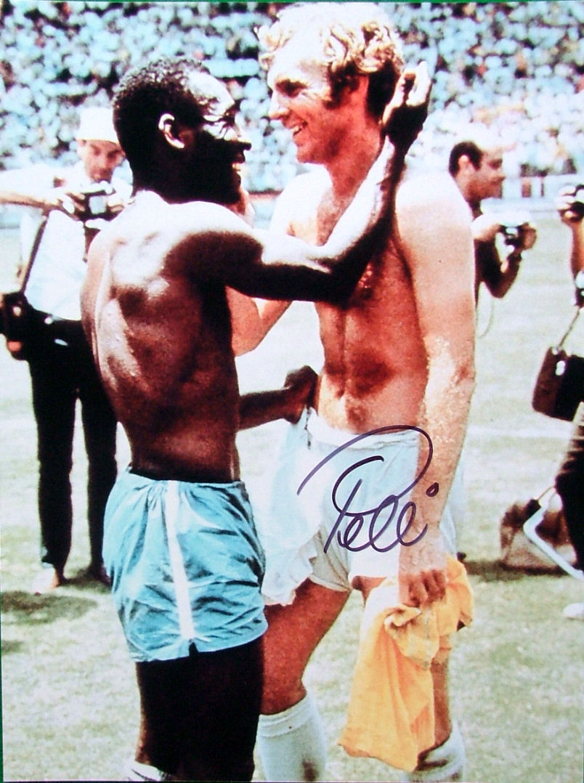
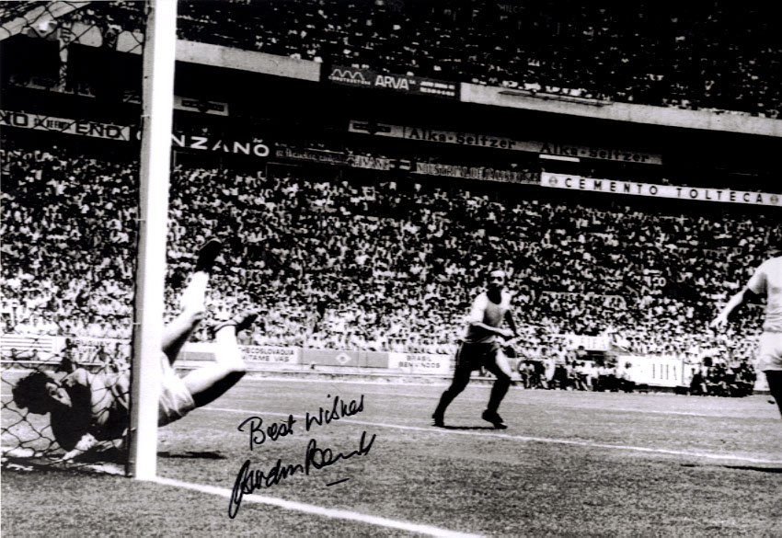
Pele with Bobby Moore that save by Gordon Banks

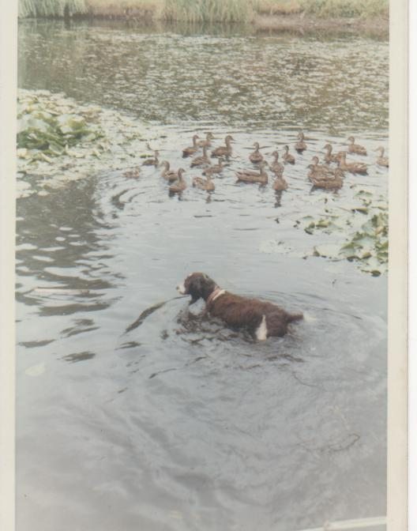
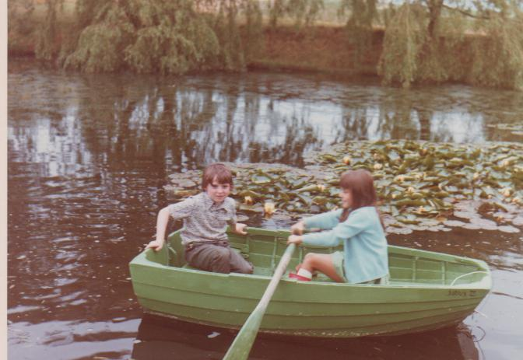
On 5th June 1970 Julian and Elisabet had a 9½lb baby boy. We went to his christening which took place on July 18th at the Swedish Church in Harcourt St, London. They named him Nicholas Edward William Baldwin. Was there some Royal connection in the family that we didn’t know about? I didn’t see the Queen there, but she might have been busy. True to form we couldn’t just go home after the christening. We drove on to Hole Farm in Essex to stay with Barry & Muriel. While we were there, Uncle Frank and Auntie Susan came over to visit, with two more cousins of mine, Andrew and Ian. We also went to see Nanna. When we did go home, we took Mark Bonner with us. How the hell did we all get in the car? Mum, Dad, Charlie, Dave, Fiona, Mark Bonner, me and Jenny the dog. Not only that, Jenny smelled of the Hole Farm duck pond.

On a date with Penny Bonner watch out Ducks, Jenny’s coming

You may recall me telling you about my brother Charlie being a diabetic. Well it seems that Mum has developed it as well. The doctors had done lots of tests and thought that she could control it with tablets. I hoped this diabetes wasn’t contagious as I didn’t really fancy catching it.

1970 Facts & Figures

Jan 23rd - The first Jumbo Jet landed at Heathrow Airport.
April 17^{h} – Apollo 13 returned safely to Earth, after an explosion on board.
May 28th - Bobby Moore, England football Captain, was held in Columbia for 2 days, accused of theft.
June 19th – Edward Heath, the Tory candidate, surprisingly won the General Election. This was despite a Presidential-style campaign by Harold Wilson, where he cast himself as a calm Baldwinesque figure.
June 21st - Tony Jacklin became the 1st Briton to win the US Open Golf Championship for 50 years.
Nov 20th - More than 150,000 people were killed by a tidal wave in East Pakistan.

Deaths
Feb 2nd – Betrand Russell, British Philosopher, died aged 97.
June 7th – E. M. Forster, British Author, died aged 91.
June 11th – Alexander Kerensky, Soviet Leader Mar – Oct 1917, died aged 89. – I think Dad knew his son.
July 27th – Antonio de Oliveira Salazar, Portuguese dictator 1933 - 69, died aged 81.
Sept 18th – Jimi Hendrix, US Guitarist, died aged 27, drugs overdose.
Oct 4th – Janis Joplin, US Rock singer, died aged 27, drugs overdose.
Nov 9th – General Charles de Gaulle, French Statesman, died aged 79.
Dec 26th – Lillian Board, British Athlete, died of cancer, aged 22.
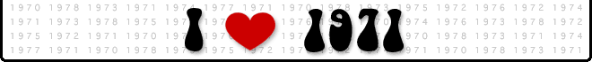

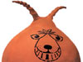
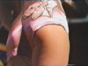
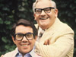
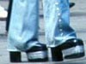
Two Ronnies Platform Shoes

Space Hopper Hot Pants Two Ronnies Platform Shoes
With the money I got for Christmas I decided to splash out and blew it all on the game ‘COPPIT’. ‘Coppit' was a game that many people will remember from their childhood, and was enjoyed by the whole family. It was an exciting, fast-moving game, where you capture opponent's pieces, carry them back to your base, and 'imprison' them there. The excitement (and frustration) comes when you are halfway back to base with your 'prisoner', only to find that you are ambushed by another player, who will now try and capture both you and your prisoner! Object of the game is to be the last player with a playing piece, or pieces, left on the board. Hey, it was 1971, we kids were easily pleased!
In January 1971 Dad noticed that I’d started to show an interest in his diaries. Little did I know that I would be writing about them, some 30 odd years later. Dad has got to have the neatest handwriting of all time. He always bought a small ‘Collins’ diary and wrote using a blue fountain pen. They weren’t the most amusing literature you’d ever read. Infact he made ‘Diary of Anne Frank’ look like a comedy novel. One thing they were though was detailed. Names, places, facts, bridges! I’m sure you’ll agree to keep a diary for over 40 years is some achievement.
I started to get worried at the end of January, as I overheard Dad on the phone (to Dobbie, Sandford, Fawcett & Partners) asking for a job as chief Resident Engineer in the North East (Middlesbrough)! The North East, do you know where that is? I’ll tell you shall I? It’s in the North and East a bit! I was a born and bred Bristolian and never thought I’d ever leave Bristol. Another worrying thing was that they were offering a salary of at least £4,000 a year. OK, you laugh at £4,000 but look at it another way. Our house (56 Station Road) was worth about £9,000. So nowadays to earn almost half the value of your house, you’d have to be on well over £100,000 pa. Not laughing now are you?
Back in those days school was a bit different. You started school when you were 5 years old, not when you were 4 and a bit. The school year started in September, not January for Reception class, then year 1 the following week. The first 2 years were at infants’ school, then you transferred to a junior school for 4 years, then you went to secondary school for 5 years, till you were 16 years old. Say you were in the 4th year of secondary school and someone asked you what year you were in, your answer would be “4th Year”. Not, “I’m in Year 17”. OK I‘ve exaggerated slightly, but you get my drift. So why is 6th form College still called the same? Shouldn’t it be 12th form college? Anyway, the point I was trying to make was that, as I was about to turn 7 years old this year, that meant the move from infants to juniors was looming large. If you were lucky infants and juniors would be in the same school, but I wasn’t, lucky that is.

So in February I went with Mum & Dad to Avon Primary school for a meeting with the Headmaster, Mr. R.M. Maxwell (hang on, wasn’t he that newspaper bloke who nicked everyone’s pension, then mysteriously disappeared off a yacht. Thinking about it, he seemed more interested in whether Dad had made sufficient retirement arrangements, than if I wanted to go to his God-forsaken school). Despite my reservations I signed a 4 year contract, on 5 bottles of milk a week, with extra biscuits, based on appearances. However if dad took this job up north, I would be looking for a Middlesbrough Primary School to step in and rescue my career.
15th February 1971 was D–Day (Decimal Day). Fortunately I never really understood the ‘Old Money’, so it wasn’t too much of a change for me. Mum, on the other hand couldn’t believe they were changing to a currency where £1 = 100 pence, 10p = 10 pence, 20p = 20 pence, 50p = 50 pence. How would anyone be able to work out what something costs?
In old money everything had a pet name. £1 = 240d (That’s d for Pence), or 20 Shillings. We had Farthings, Half Penny (ha' penny), Penny, Tu’ pence (no coin but name given to 2d), Thruppence (3d, Truppenny bit), Sixpence (6d, Tanner), Shilling (12d, Bob), 2 Shillings (Florin), and Half Crown (2 Shillings & Sixpence, Half a Crown)
A shilling was commonly known as a ‘Bob’. Charlie and Dave, who were Boy Scouts, would collect money by doing ‘Bob-a-job’, meaning simple chores such as washing a car or cleaning shoes for a shilling. If this seems a very small sum of money, remember that there has been inflation since then. I got 1d for each year of my age for pocket money each week, so when I was 7 I got 7d a week. People would sometimes say to me, ironically, "You must be worth a few bob!" meaning, that I must be worth a lot of money. I wish!

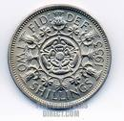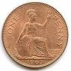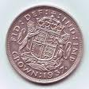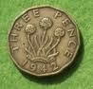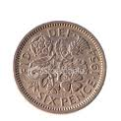

In March we had a French kid come and stay. Dave was studying French at school and part of the deal was one of them came to stay in England and then Dave would go over to France to stay with them. Our student was called Marc Tropis and he didn’t have a very good start to his trip. His flight from Bordeaux was diverted to Cardiff and then again to London. He eventually landed at Lulsgate Airport at 3.30am and it was 4.30am by the time he got to bed. Later that day David and Marc went to tea at the council house with the Lord Mayor. How important were they?

At the breakfast table Marc said “Madame Baldwin, you have crap for breakfast?” Listen pal, this cereal I was eating was Magic. In the advertisement for Ready Brek breakfast cereal, children were queuing in the school playground, jostling to get out of the wind and rain but the boy with the Ready Brek glow was in no hurry, with the slogan "Central Heating for kids”. I later found out that he was asking for a crepe, it’s a sort of pancake. Why didn’t he say that in the first place?

After breakfast Marc went to school with David. I bet he was good in the French lesson. We weren’t the only ones with a French kid staying. In the evening Dad took us on the ‘Betty Brown’ and we had four of them with us. We certainly knew how to show these guests a good time, not only did they get a boat trip up the Avon, we saw a dead body floating in the water. Not your average school Field Trip. Let that be a warning to you French kids, buy British beef, or look what might happen to you.
Charlie and Dave took Marc to The Scala, to see ‘The Italian Job’ and ‘Monte Carlo or Bust’. Do you notice something there? Yes, two films for the price of one. In the 21st Century, a new term has entered the English vocabulary, ‘CINEMA PRICES’. Basically, it’s used to express your disgust at something that is ridiculously overpriced (e.g. everything at a theme park, football matches and any spectator event).
- 1971 – You paid next to nothing for your ticket, for two films. Bought your Popcorn and family size Maltesers in the foyer and then would rush back for your ‘Westlers’ Hot Dog after the Pearl & Dean advert saying “An hour from now, you’d wish you’d had one.”
- 21st Century - Pay on average £6 each for one film. Stop at the Petrol station on the way to buy your drinks, chocolate and crisps. However you still end up being nagged into buying a Large Popcorn at the cinema. The clever pricing structure means you never buy small or medium. Small -£4.50, Medium -£4.75, Large -£5. Then they throw in another marketing trick. Buy large popcorn and get £1 off a large drink. So you only pay £3.50 for a drink instead of £4.50. How could you possibly resist the chance to pay only £3.50 for a litre of watered down Coke? When you finally sit down, you’re told you can’t smoke, eat popcorn loudly (where’s the fun in that), to turn off your mobile phone and watch out for pirates (they’re the ones with an eye patch, parrot on their shoulder and wooden leg). You take your son, who invites his mate. When you pick up his mate, his Mum comes to the door and gives you a fiver. You respond by saying “Are you sure?” (In the tone of voice that suggests that she’d just offered to pay your mortgage for a month). All cinemas are now ‘out-of-town’ and have a McDonald’s strategically placed so that you can’t avoid it. Your son’s mate has already got sweets, crisps, cinema admission, share of large popcorn and drink out of his fiver, but he’s about to finish it (you) off with a McDonalds. He offers to just have a Happy Meal, but by this stage you’re beyond care. Go large, super size me, have a McFlurry, chocolate donut, milkshake for an extra 30p! Add to this you have to phone your daughter (who didn’t want to see ‘Spiderman 8’), get her a McDonald’s and also give her a fiver (bargain), being money she’s saved you by not going to the cinema.
- So let’s tot that up - 3x Admission £18, sweets, crisps & drinks £6, large Popcorn/drink £8.50, 4x McDonalds £16, £5 for not going to the cinema, less £5 from Son’s mate (whoopee!!). – Total Cost £48.50.
Charlie’s main hobby was butterfly collecting. If you ask me it's a bit cruel. He’d catch them in a net, and then gas them in a jar, and then just to make sure he’d stick a pin through their body. He didn’t always do this however, as one time he had a ‘Swallowtail’ hatch out. He would display some of the best butterflies in a glass fronted case and hang them on his bedroom wall.
We were big friends with a family that lived just along the road from us, the Kelle’s. I’m not sure what Mr Kelle did, I think he was a businessman. I suspect he might’ve been German, with a name like Adolf. Not exactly a popular baby’s name in 1930’s Britain. They had three daughters, Barbara, Liz and Hilary. Barbara was about the same age as Fiona and they used to hang about together. I was a similar age to Hilary and we used to play together (no funny business, I was only 7 remember). They had a massive house, which had the loft converted into a big games room.
Hilary used to let me ride on her scooter, which was great fun until the day I was going down Station Road (it was on quite a slope near our house) and lost control of the scooter and crashed into a tree. I tried to pretend it didn’t hurt, but when I got inside I sobbed as Mum applied the TCP ointment.
On my 7th birthday I had a little bash which Hilary came to, along with Peter Brandt, Timothy Leach, Clive Mabey, Craig Massey, Andrew Mabey, Andrew Petrie, Tracy Light and Rachel Arnold. How popular was I?
On the 9th July I had another cousin come into the world. Auntie Susan and Uncle Frank had a daughter and called her Fiona Louise Turner. Couldn’t they have thought of another name? I had a sister called Fiona. It was going to be well confusing. Fiona had two older brothers, Fiona Turner that is. Mind you, Fiona Baldwin had got two older brothers as well. I told you this was going to be confusing. Maybe they could both be known by their middle names. Fiona Turner could be called Louise and Fiona Baldwin could be called Louise. Oh forget it, one’s a baby and the other one is 12 years old, I think I’ll be able to tell the difference.

Tour de Grande Britannia
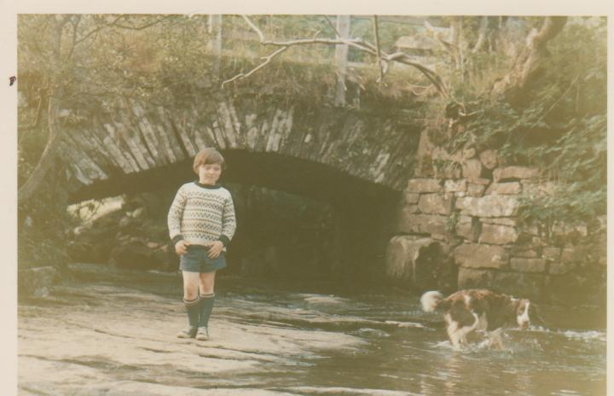
You know I’ve told you about our holidays and driving miles to get there. Well this year we were topping anything that had gone before. This one could be described as a two week Tour de Grande Britannia. Our first destination was the Lake District (no short distance). We camped at Hollows Farm in Grange-in-Borrodale. We visited Lake Buttermere and Dad and I climbed up Scale Force Cascade. After a couple of days in the Lakes, we drove 237 miles to another camp on another farm near another lake. By now we were in Scotland and the farm in question was by the shore of Loch Leven. Most people would think, OK that’s far enough (well over 400 miles) lets head back now. Not my parents! We visited Kinlochleven and then Fort William, where we were all treated to a tradional Scottish gift. Fiona got a mini kilt, Charlie got a Fair Isle sweater but I got a Tam-o-Shanter. You know, one of those dodgy tartan berets with a bobble on top. Like I was going to wear it in Bristol? They could at least have got me a ginger wig, so I could’ve gone round saying, “see you Jimmy”. You may have noticed that Dave didn’t get anything. That’s because he was on the return visit to France for four weeks, with Marc Tropis.
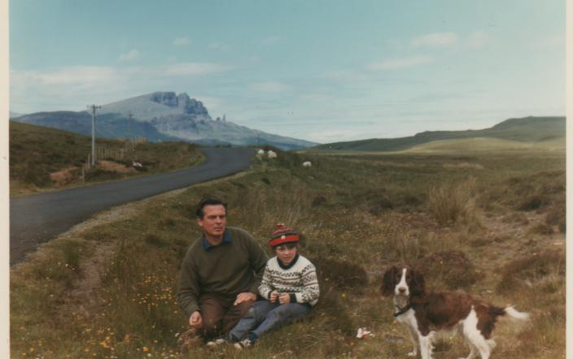
Me & Jenny on Holiday ‘Tam-o-shanter’

By this stage of the holiday we’ve gone so far north, that we were running out of land but after going along the narrow winding road to Mallaig, we caught the ‘Clansman’ Ferry boat to Skye. We stayed in the Toravaig Guest House. We took a rowing boat out in Portree Harbour on a lovely sunny day. We finally decided to turn round and returned to Loch Leven via the ferry to Kyle of Lochalsh and Glen Shiel and Glen Garry and Glen Hoddle (no, I made that up!). We couldn’t go to Scotland and not go over the Forth Road Bridge. So a detour was made to accommodate this. On we went through the ‘Scotch Mist’ via Edinburgh, via Newcastle (England) to a camp near Richmond, We went to the seaside at Redcar, Saltburn, Whitby and Robin Hood’s Bay (little did we know at the time, that these would become local seaside resorts in the near future).
The following day we went to York, which was celebrating its 1900th anniversary (I don’t think they did cards for that age). We went to the ‘Castle Museum’, which had fascinating old shops and cobbled streets. Charlie climbed to the top of York Minster, while Fiona and I climbed Clifford’s Tower. We spent our last day travelling round the Yorkshire Dales, visiting Wensleydale, Buttertubs Pass and Swaledale. We found waterfalls at Aysgarth, Hardrow (100ft drop) and Reid (Kisdon Force). We still weren’t going home yet though. To ensure that the holiday qualified for a Tour of Britain award, we had to spend one night in a South East county. So we stayed with Barry and Muriel at Hole Farm in Essex. We went to see baby Fiona, Nanna and various other relations in the area. We finally got home taking Jacky Bonner with us and leaving Charlie to work on the farm.
While on holiday Dad phoned Grandad to hear that Vernon had an operation on July 23rd, to remove a brain tumour. Now I was no medical expert but that sounded serious. On our return from holiday, Dad went to visit Vernon in Frenchay Hospital. At first the news was encouraging, that he wouldn’t need a second operation but a couple of weeks later he learned that he needed the second operation for his tumour, from a doctor who brought some students to see him in Frenchay Hospital. Vernon had the second operation on 2nd September and went into intensive care to recover from his operation. Grandad found out a few days later that not all of tumour was out. This was the start of a long period of unconsciousness for Vernon.
Remember I was telling you earlier that Dad was thinking of going for a job in Middlesbrough, well he got the job and accepted it. I had no say in the decision to ruin my life. We were going to lambs to the slaughter with our West Country accents and Southern ways. Worse still I was going to have to start two new schools within the space of 2 months.
I started at Avon Junior School, Barracks Lane, on Wednesday 1st September. It was OK, but what was the point in making new friends that I was never going to see again? We did go on a school trip though, to the Kennett & Avon Canal at Limpley Stoke nr Bath. Don’t be fooled by the map below, in 1971 this section of the Kennett & Avon Canal was much neglected. The water looked like pea soup, but I think they’ve sorted it out since then.

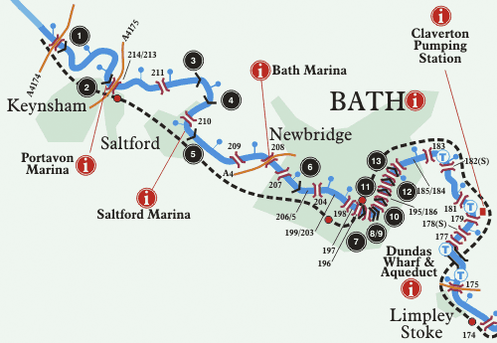

Middlesbrough

So I only went to the school from 1st September to 29th October, because on the 3rd November we left 56 Station Road forever. After packing all our belongings into the C. Reed & Son Ltd removal van, we said goodbye to Shirehampton and drove north to Teesside. We stayed our first night at ‘The Golden Eagle’ Hotel in Thornaby. Meanwhile the removal van broke down near Nottingham. The following day we got the keys to 6 Thackeray Grove, Linthorpe, Middlesbrough. The removal men (Bob and Alan) finally arrived in the afternoon, after their vehicle problems. We all helped them unload the van (well I didn’t) and they stayed the night, probably because we now lived so far north it was like another country.

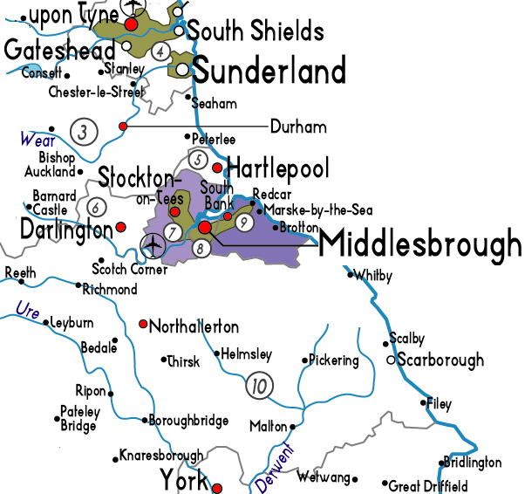

We went to Middlesbrough Town Centre on the Saturday and I saw Father Christmas in ‘Binns’ Department store. On the Monday Dad started work and met Glen Preston, who was C.R.E. (Chief Resident Engineer) on the A19 improvement. On the same day Charlie started at Middlesbrough High School, David and Fiona started at Boynton School and I started at Green Lane Primary School, Middlesbrough.
Dad had noted in his diary that I ‘filled my pants’ at school. He hasn’t elaborated on that though and you’re probably thinking “what has he filled his pants with?” Money, sweets, bacon butties, chocolate (well, sort of). OK, I’d shit myself at school! It happens, well it had happened to me. Who hasn’t? [Imagine deathly silence and Tumbleweed, at this point]. Strictly speaking I wasn’t actually at school. We were at some school concert at the church in The Avenue. I thought I could sneak out a crafty fart during the singing, but unfortunately I followed through. While everyone was thinking “Jesus Christ, praise the Lord”, I was thinking “Jesus Christ, I’ve shit myself”. It wasn’t as if I could hide the fact, as until the age of 11, we were forced to wear short grey trousers. So with a brown stripe making its way down my leg, I quickly found a teacher, explained my predicament and was allowed to make my way home. I ran (well moved as fast as I could, with my buttocks clenched together) down The Avenue, along Emerson Avenue and into Thackeray Grove. Mum opened the door and asked why I was home so early. I said I was feeling unwell and school had told me to go home and immediately run upstairs and wash my pants and trousers with soap, shampoo, bubble bath, basically anything I could find in the bathroom. That last bit was a half truth, I did do that, but school didn’t tell me to. Kids these days have it easy, when it comes to shitting themselves at school. They have long trousers and automatic washing machines, lucky bastards!
It wasn’t long before Charlie and Dave made their first visit to see Middlesbrough F.C. play at Ayresome Park. On Saturday 20 November they went to see Middlesbrough (BORO) play Orient. in league div 2. (Old money). Boro won the game 1 -0 with John Hickton getting the all important goal. I was still to discover the joy and despair of supporting a football team.
I was enjoying going to Green Lane School, but Dave wasn’t happy at Boynton. So much so that Mum and Dad managed to get him into Acklam Hall School. Charlie wasn’t finding Middlesbrough High School very friendly either, but he stuck with it. Mum and Dad went to a Sherry party at my school and met my teacher, Miss Anne Pinder.
Auntie Vi and Uncle Doug came to stay with us for our first Christmas in Middlesbrough. On Christmas Day we went to our neighbours, the Lewis’s for drinks. I say that like I had a few pints, couple of Scotches and a bottle of wine. I probably had an orange squash! On Boxing Day we went for a drive with Vi and Doug to a local landmark, Roseberry Topping. Actually Boxing Day in 1971 was the day after Boxing Day. Vi and Doug went home, Charlie and Dave went to see Boro draw 2 – 2 with Carlisle United and Fiona and I went to see ‘Jack and the Beanstalk’ at the ‘Little Theatre’.

1971 Facts & Figures
Jan 2nd - 66 people were killed when crowd barriers collapsed at Ibrox Park, Glasgow.
Feb 15th – Decimal Day. Britain got a new decimal currency.
Feb 20th - Dictator, Idi Amin appointed himself President of Uganda.
Mar 26th – Civil war erupted in East Pakistan, after Sheikh Mujibur Rahman declared the independent state of Bangladesh.
May 8th – Arsenal sealed the League and Cup double, with a 2 – 1 win over Liverpool in the FA Cup Final.
July 2nd - 19–year-old half-aboriginal girl, Yvonne Goolagong, won the Women’s Singles title at Wimbledon.
July 25th – The first ever heart and lung transplant was performed by Dr. Christian Barnard.
Oct 9th – Emperor Hirohito arrived in Britain on a state visit, much to the annoyance of former Japanese POW’s.
Nov 5th - Princess Anne was named Sportswoman of the Year, for her performances as a show jumper.
Deaths
Jan 6th - Sonny Liston, US heavyweight boxer, died aged 38.
Jan 10th – Gabrielle ‘Coco’ Chanel, fashion revolutionary, died aged 87.
April 6th – Igor Stravinsky, Russian composer, died aged 88.
April 21st – Dr. Francois “Papa Doc” Duvalier, Haitian Dictator, died aged 61.
July 6th – Louis Armstrong, US singer and trumpeter, died aged 71.
Sep 11th - Nikita Khrushchev, Soviet Statesman, died aged 77.
Dec 18th – Bobby Jones, US golfer, died aged 69.

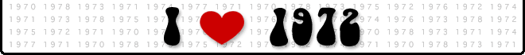

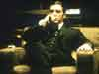
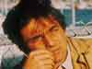
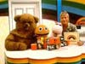
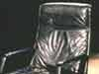

Mastermind Rainbow The Godfather Columbo

We were going on a ‘Baldwin European Vacation’ and because there were so many of us, we bought a brand spanking new Camper Van. When I said we were going, that should read they were going. I was 8 years old and going to be left ‘Home Alone’. Strictly speaking I wasn’t being left alone; I was going to stay at ‘Hole Farm’ with Barry and Muriel. Ok, to be honest with you I was asked to go on holiday, but I didn’t fancy travelling 500 miles a day, for 3 weeks, eating dodgy foreign food.
We got the Volkswagen ‘Danbury’ Caravette, Reg No. EDC 788K, on the 2nd May and Dad took us all out for a ride to Durham. It was well cool, it had loads of seats and these could be made into a bed at night time. There were also two hammocks in the roof, which could be raised so that you could get into them. It also had a sink and cooker. We were the envy of the neighbourhood.
The holiday of a lifetime (that I never went on) started on 23rd July. We left Jenny at Roslin Kennels, and then I was left at Hole Farm kennels!
I might as well tell you about this holiday and compare it with my holiday.
Day 1 – Them Took Hovercraft to Calais, drove through Belgium to Germany, via Dunkirk, Ostend, Brussels, Louvain, Aachen, Cologne, Bonn and finally Koblenz. 307 miles
Me – PYO strawberries. 0 miles
Day 2 – Them Visited the Rhine Bridge at Koblenz. Then drove up the Rhine past Boppard, St. Goar and Bingen. Visited the Stadelschen Kunstinstitut in Frankfurt. After that took the Autobahn to near Stuttgart and camped at Leonberg/Eltingen. 212 miles
Me – PYO strawberries. 0 miles
Day 3 – Them got up early and reached Munich by 11 am. Then on through picturesque Bavarian villages. Camped for the night at Weissach. In the evening they went to Rottach – Egern and went to an inn with a zither player. 192 miles
Me – PYO strawberries. 0 miles
Day 4 – Them Charlie fished from a boat in Lake Tegernsee, David and Fiona swam in the heated pool at Rottach – Egern. Mum and Dad visited Aachental in Austria with a small church on a hill. Later they drove to Prien by Lake Chiemsee and then to Salzburg and dined at the Glockenspiel restaurant overlooking Mozart Square. 199 miles
Me – PYO strawberries. 0 miles
Day 5 – Them after heavy overnight rain they packed up camp at Weissach and set off for Italy. Went via Innsbruck and Europa Bridge, through the Brenner Pass. Made camp for the night at Streissand (not Barbara). 128 miles
Me – PYO strawberries. 0 miles

Day 6 – Them Continued journey through Dolomites via Cortina d’Ampezzo to Venice and camped at Joker Camp near Cavallino. The kids went straight into the Adriatic for a swim. The weather was hot and sunny. 138 miles
Me – PYO strawberries. 0 miles
Day 7 – Them Mum and Dad took the boat from Punta Sabbioni to Venice. Had a coffee in St. Marks square and lunch by the Rialto Bridge. Then caught a river bus down the Grand Canal. When they returned to Joker Camp, the 3 kids were all sunburnt. Responsible Parenting, I don’t think! 0 miles
Me – PYO strawberries. 0 miles
Day 8 – Them spent the day lazing in the sun and swimming in the sea at Cavallino. Charlie had a ride on the Go-Karts. 0 miles
Me – PYO strawberries. 0 miles
Day 9 – Them everyone went on a trip to Venice and walked from St.Marks Square to the railway station. They returned via waterbus and got caught in a Thunderstorm. 0 miles
Me – PYO strawberries. 0 miles
Day 10 – Them a very hot day spent at the Joker camp and in the sea. 0 miles
Me – PYO strawberries. 0 miles
Day 11 – Them on the move again, leaving Venice and taking the Autostrada to Milan. Saw the Duomo (whatever that is?) and the Grassi collection at the Villa Communale. Later left Milan for Genoa then took the coast road and found a camp near Rapallo. 298 miles.
Me – PYO strawberries. 0 miles
Day 12 – Them drove from Rapello through San Margherita to Paraggi, where they lunched and bathed on the beach. After lunch Mum and Dad walked to Portofino and back. The Mediterranean was a beautiful blue. 15 miles
Me – PYO strawberries. 0 miles
Day 13 – Them dad suddenly realised they were short of Lira. Managed to buy coupons for 30 litres of petrol at Genoa, and then took the ordinary roads via Alessandria, Turin, Susa and the Mont Cenis pass to France. They stayed the night at Lanslebourg. 186 miles
Me – PYO strawberries. 0 miles
Day 14 – Them awoke early in the mountains. Drove to Lake Anneey where they rowed a boat and swam. Then continued via Geneva, Gex and over the Jura mountains. Had an evening meal near the River Ain at Pont du Navoy and camped at a site by Lac de Chalain. 193 miles
Me – PYO strawberries. 0 miles
Day 15 – Them cashed their last £30 of traveller’s cheques at Lons-le-Sannier. Joined the Autoroute at Chalons-sur-Saone and drove to Paris, arriving at 5pm. Found a camp site at Maison-Lafitte by the River Seine. 276 miles
Me – PYO strawberries. 0 miles
Day 16 – Them visited the Palace of Versailles in the morning. In the afternoon went to Notre Dame Cathedral. Later, visited Montmarte and walked round the Place du Tertre where the artists were. Also went to the Sacré Coeur and the kids went up to the Dome. 54 miles
Me – PYO strawberries. 0 miles
Day 17 – Them back to Paris and of course the Eiffel Tower. Owing to lack of funds they only went to the first level (shame, like they hadn’t done much on holiday). After lunch they visited the Louvre (Mona Lisa and all that). 0 miles
Me – PYO strawberries. 0 miles
Day 18 – Them left the camp at Paris and drove via Pentoise, Beauvais, Abbeville to Boulogne, where they stopped to buy me a present. Oh, they still remembered me? I was 8 years old when they left; I was almost a teenager now! Hang on; they’d stopped to buy me a present. I thought they’d run out of money days ago. I couldn’t wait to see this gift, what could it be? A litre of fuel? Duty Free fags?
I wanted at least a replica Eiffel Tower. Surely they could get one cheap that only goes up to the first level, Ha Ha! They returned to England on the 8pm Hovercraft from Calais. 161 miles
Me – PYO strawberries. 0 miles
Day 19 – Them after almost 3 weeks away they finally arrived back at Hole Farm at 10 am. David stayed at the farm and Jackie & Penny Bonner came back to Middlesbrough with us. We arrived home just after 8 pm after picking up Jenny from the kennels. 95 miles
Me – PYO strawberries. 0 miles
– Them 2454 miles
- Me 0 miles
Ok, I might’ve gone a few miles, swimming or something, but most of it was spent on the Farm. However staying behind had one advantage,

Jeux Sans Frontières “Games without Frontiers”.
The winners of the GB heats of “It’s a Knockout” would compete against other teams from other European countries. They would dress up in stupid costumes and compete in zany games. On the first Friday night staying on the farm, we were glued to the TV. This was to be a memorable night with Salisbury (representing GB), pulling off a great victory by 4 points over La Chaux-de-Fonds (representing CH, that’s Switzerland to you and me).
BBC1 Transmission: Friday 28th July 1972, 7.45-9.00pm
Recorded: Thursday 25th May 1972
Venue: Spa, Belgium
Theme: The Trades of the World
Teams: Spa (B) v. Anglet (F) v. Hirschau (D) v. Salisbury (GB) v. Franeker (NL) v. Ostuni (I) v. La Chaux-de-Fonds (CH)
Games: ‘Slating the Roof’, ‘The Plumbers’, ‘Erecting the Aerial’, ‘The Weather Vane’, ‘Litres of Wine’, ‘The Hairdressers’, ‘The Millers’, ‘The Painters’ (Fil Rouge) and ‘The Chimney Sweeps’
Result: | Team: | Points:
1st  2nd  3rd  4th  5th  6th  7th | GB • Salisbury  CH • La Chaux-de-Fonds  D • Hirschau  F • Anglet  NL • Franeker  B • Spa  I • Ostuni | 48  44  38  28  26  25

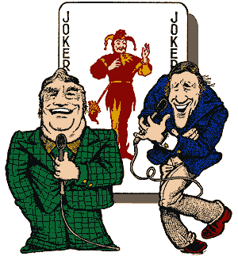

Eddie Waring and Stuart Hall

Nanna (Mother) came to stay with us on February 9^{th,} Dad met her at Darlington Station. I hoped she’d brought some candles with her! The British coal miners were on strike and the Government kept flicking the ‘leccy’ on and off as and when they pleased. Now you might think Nanna had come for the weekend or maybe even a week. No! She was here for a month. I think it must’ve been a novelty for people having friends and relations north of Watford. On the 18th February we really had a house full of people. Nanna (now on the electoral roll) of course and Barry & Muriel, and Mark came for a long weekend. At least we got to visit lots of places. We went over the North York Moors to the beach at Saltburn. Then we went to Weardale and Teesdale and visited High Force waterfall and the Bowes Museum. Nanna eventually returned to Essex on the 8th March. Conveniently the coal strike was over by then. I reckon she wanted to save on the electric; mind you the money she’d taken off us kids at Canasta (card game) would’ve heated her house for a year.
At Easter it was our turn to stay with someone. We went to Bristol to stay with Vi and Doug. Fiona went to stay with her friend Barbara Kelle, Charlie and Dave went to see Bristol City play Swindon (2 – 1) and I went with Mum and Dad to see Grandad and Auntie Barbara in Fishponds, Vernon came home for Easter. On Easter Sunday we went to Weston-Super-Mare and I rode on a donkey on the beach. On Easter Monday the whole family went to tea at Grandad’s. Afterwards Dad and Grandad took Vernon back to Glenside Hospital.
On 12th April I lost one of my front teeth, and then I lost the other one on 29th April. Two visits from the Tooth Fairy in one month, this tooth-loss game could’ve been a big earner. However there was limited stock available. Later in the year I had to have two other front teeth out by gas. I was expecting ‘Double Bubble’ from the TF for having to go through such an ordeal but only got the ‘Falling out by natural causes rate’. What’s the point in giving us teeth that are only going to last until we’re about 8 years old? Might as well just give us a better set that are going to last.
Another cousin was born this year. On 13th August, Julian and Elisabet had their second child, Peter Baldwin. His brother Nick was 2 years old now.

FOOTBALL FEVER
1972 was the year I finally got into football… One of the reasons for this was my birthday being 4th May and the F.A. Cup Final was always the first Saturday in May. I recently asked an Internet football forum, “Why were the Cup Finals in the 70’s more memorable, than more recent Cup finals?” Everyone’s answer was the same. “The only Live football on TV was The F.A. Cup Final, the European Cup Final and Internationals”. We only had 3 TV channels, BBC1, BBC2 and ITV, but the build up on BBC and ITV started about 5 hours before kick off.
FA Cup TV build up included – It’s a KnockOut – between supporters of the two finalists. There’s an old wives tale that, if you won the It’s a Knock Out contest you lost the final. So I’m assuming Arsenal won.

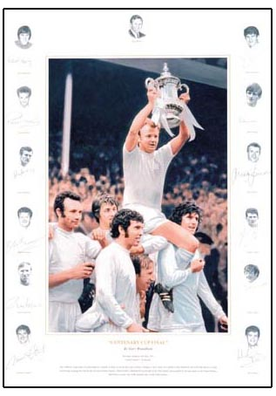
Leeds Utd winning the 1972 F.A. Cup

The ‘72 Cup Final was between the Double winners from 1971, Arsenal and Leeds Utd. Arsenal were obviously the favourites, but the game ended 1 – 0 to Leeds Utd, with a diving header goal by Allan Clarke winning the game. I was completely spellbound but little did I realise my life was going to change forever.
As my love of football grew the next step in my development was to go to a game. My wish was granted on Saturday 23rd December 1972. Auntie Vi and Uncle Doug, had come to stay for Christmas and we’d gone shopping in Newcastle. Someone suggested that while the women went shopping, us men go to see Newcastle Utd. v Manchester City at St. James’s Park. “Oh go on then!” It was a great atmosphere inside the ground, but I couldn’t see a thing (height related issue). However Uncle Doug came to the rescue and lifted me onto his shoulders and into the Promised Land. The game finished 2 – 1 to Newcastle. When I got home I checked out my local team, Middlesbrough and vowed to myself that 1973 was going to be a frenzy of football fever.
My brothers and sister were quite a bit older than me, hence there was more to their life than football and It’s a Knockout. How could that be?
Charlie was 17 and was into girls, alcohol, girls and alcohol. Charlie had also grown his hair quite long. Well it was 1972. Dad didn’t like this; he was brought up a short back and side’s boy. Charlie went to a discotheque at the Golden Eagle and didn’t get home until 1 am. Dad had a dust up with him the following day and got ready to cut his hair but he ran away. He cut Dave’s hair instead. He did go to the barbers the following day, but it didn’t alter his appearance. On 17th Nov Charlie went for a birthday party drink at the Linthorpe Hotel “The Linney”. A plain-clothes policeman and policewoman questioned his age and came to see Mum and Dad at home. Charlie was in so much trouble, I can see the hair trimmers being readied on No.1.
David, who was 16, had a girlfriend called Julia, but this other girl called Alison Hunter had this idea that she was also Dave’s girlfriend. I suppose you could say she was a stalker. Anyway she came over on Boxing Day to see David and stayed to play ‘Flutter’ with the family. Dave knew he’d have to tell her, before it got out of hand.
Fiona was only 13 but seemed to change her boyfriend every week. Dad had noted that on October 30th, “Fiona had a tall boyfriend, David Knight, call at the house”. He probably wasn’t that tall, Danny DeVito would look tall next to Fiona. A few weeks later, after a tip off by yours truly, dad caught Fiona kissing Simon Mortimer (no mention of height) in the Dining Room. He sent him packing! Don’t you just love younger brothers, little bastards!

I think Dave’s New Year resolution was to play more sport. On 10th January he enrolled in evening golf coaching at Bertram Ramsey School for 50p. He was taught by Mr. Scott, the Pro from Marton. Then 2 days later he was selected for Acklam Hall’s Rugby XV. After his first golf lesson, he decided to do a bit more practice at home and proceeded to smash a light bulb! On Saturday 16th Jan, he made his debut for Acklam Hall and scored 2 tries, in a 39 – 0 thrashing of Grangefield of Stockton. Golf was to become a complete obsession for Dave (it would’ve been easier for Dad to mention in his diary, the days Dave didn’t play golf). He joined Middlesbrough Golf Club and would play 8 days a week if he could. If he wasn’t playing he’d be caddying or spotting balls. When he started off he was scoring over 100, but by the end of the year he was shooting 81. All of this was done playing left handed, imagine what he’d score if he played right handed. Fiona was also keen on sport, mainly Ice Skating. Charlie was keen on fishing, which was just as well as he wasn’t the most talented Sportsman this country had ever produced. Dad bought me some football boots and socks. I even learned how to tie my own laces; I should hope so at 8 years old. I was also showing signs of being a talented golfer, having scored a Hole-in-One at the final hole of the Whitby Crazy Golf. That won me a free game next time we went. Unfortunately the TV cameras weren’t there to capture the moment.

Munich 1972

1972 was Olympic year and was held in Munich, West Germany. It was also my first memory of the Olympics. It turned out to be one of the most memorable of all time, for both sporting achievement and even more so, a terrorist atrocity.

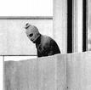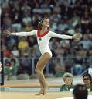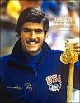
Palestinian Terrorist Olga Korbut Mark Spitz

The games were marred by what has come to be known as the ‘Munich massacre’. On 5 September a group of eight Palestinian terrorists belonging to the Black September organisation broke into the Olympic Village and took eleven Israeli athletes hostage in their apartment, soon killing two of them in the apartment; the subsequent standoff in the Olympic Village lasted for almost 18 hours. During a badly botched German rescue attempt at the military airport of Fürstenfeldbruck , where the captors with their hostages had been transferred by helicopter ostensibly to board a plane bound for an undetermined Arabic country, all the surviving Israeli hostages were killed by the Palestinians. All but three of the Palestinianians were killed as well. Two of those three were supposedly killed by the Mossad. Jamal Al Gashey is the sole survivor. The Olympic events were briefly suspended but Avery Brundage, the International Olympic Committee president, decided that "the Games must go on" and the games resumed a day later.
The most memorable sporting achievement was U.S. swimmer Mark Spitz winning 7 Gold Medals and Olga Korbut, a tiny Soviet gymnast who captivated the whole world with her performances. Then there was the most controversial Basketball game of all time.
The USA held a 50-49 lead, with 3 seconds remaining. The Soviets failed to score on the ensuing possession, but the clock was stopped at 0:01 after one official heard the earlier horn and the Soviets were frantically urging time-out. The clock had to be reset to three seconds but it was showing 0:50 when play began again. Again, the Soviets failed to score, time apparently expired, and the United States began celebrating, with ABC displaying the 50-49 margin as "final". However, after the vehement protests of FIBA secretary general R. William Jones of Great Britain, the referees added three seconds back to the clock due to error in re-starting the clock. Jones had no authority to intervene during a game, but his reputation was such that the officials dared not disobey him. The extra three seconds allowed the Soviet Union to have one more chance. The Soviets threw the ball down court, and Aleksandr Belov made a lay-up as time expired for the final margin of 51-50. A U.S. protest, filed after the match, was denied by FIBA and the gold medal was awarded to the Soviets. The U.S. team voted unanimously to refuse the silver medal, and to this day still have not accepted them. They remain in a vault in Lausanne, Switzerland. USA team captain Kenny Davis even has written in his will that his wife and children can never accept the silver medal. The end of the USA-USSR gold medal game remains one of the most controversial events in Olympic history and has been the subject of numerous film and television specials, including HBO's documentary 0:03 Seconds from Gold.
On June 28th they had a Summer Garden Party at Green Lane School. This was the highlight of the school year, with all sorts of stalls set up. They had Tombola, Find the Treasure, Beat the Goalie, Hook a Duck, etc. However my favourites were the Coconut Shy and the Crockery Shy. The Coconuts were impossible to knock off, I’m sure they were super glued on. The Crockery Shy was great though, nothing to win, just a rare opportunity to cause reckless damage to property, with no repercussions. Parents had donated cups, saucers, plates, dishes, tea pots. All of these were piled on shelves and you paid 10p for 5 wooden balls. The idea was to smash up as much crockery as you could. What great fun!
If you were impressed by us having a Camper Van, well at the end of the year Dad took delivery of a huge White Safari Land Rover (OPR 133L). It was intended for work, but it would ultimately prove very useful for school trips and go a long way towards making me one of the most popular kids in class!

1972 Facts & Figures
Jan 22nd – Prime Minister, Edward Heath, signed the Treaty of Brussels which will bring Britain into the European Community.
Jan 30th – “Bloody Sunday”. During a riot in Londonderry’s Bogside, British Paratroopers opened fire. 13 people were killed.
Mar 25th – The Government announced direct rule for Ulster.
Jun 18th - All 118 people aboard a BEA Trident died when it crashed minutes after take off from Heathrow.
Aug 11th – The last US Combat troops withdraw from Vietnam, after over 7 years of war.
Sept 5th – 11 Israeli athletes are killed after Palestinian Terrorists strike at the Munich Olympics.
Nov 7th – US President Richard Nixon won Re-election by a landslide over Democrat candidate Senator George McGovern.
Dec 25th – Up to 10,000 people were killed in an earthquake that hit the Nicaraguan capital of Managua.

Hits of the year – American Pie, Mouldy Old Dough, Layla, I’d like to teach the World to Sing.
TV Licence cost £12.
New TV programmes – The Walton’s, M*A*S*H, Are you being Served, Mastermind, Kung Fu, Emmerdale Farm.

Deaths
Jan 1st - Maurice Chevalier, French actor and singer, died aged 83.
Mar 29th – J Arthur Rank, British film producer, died aged 83.
May 2nd – John Edgar Hoover, US FBI Chief died aged 77.
May 22nd – Margaret Rutherford, British Actress, died aged 80.
May 28th – King Edward VIII, the Duke of Windsor, died aged 77.
Dec 26th – Harry S Truman, 33rd President of the United States (1945 – 53), died aged 88.
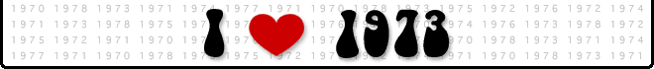

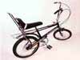
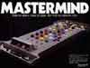
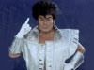
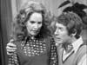
Chopper Mastermind Glam Rock Some Mothers’

Having gone to my first football match at the end of 1972, I’d assumed that it was the start of my career as a football fan. However I would have to wait a year before my obsession took hold. There was one game in 1973 that did stick in the memory though. The FA Cup Final threw together Sunderland from Division 2 against the mighty Leeds Utd, the Cup Holders. Leeds only needed to turn up to win, but Sunderland had other ideas.
The day before the Cup Final was my 9th Birthday, but this was to be the start of a tradition. The Cup Final was always the first Saturday in May and my Birthday was always the 4th May. So I would have a Cup Final Birthday Party. We would watch the game on (colour) T.V, then have Birthday tea, then go down to the field at the end of Thackeray Grove, to re-enact the best moments of the Cup Final. Strictly speaking we shouldn’t have been supporting Sunderland, as they were Middlesbrough’s local rivals, but being only 9 years old we didn’t understand deep hated local rivalry. If we were 13 years old, we wouldn’t have even ‘spat on them, if they were on fire’. As it happens Dad had decorated a cake in Sunderland colours (red and white stripes). It must’ve been a sign. Oh, by the way Mum made some cracking doughnuts.
The game started slowly and Leeds weren’t their usual dominant self. This gave Sunderland hope and on 31 minutes the unthinkable happened, Sunderland took the lead! Ian Porterfield controlled a high bouncing ball and shot home from 12 yards. Leeds suddenly woke up and lay siege to the Sunderland goal. The turning point of the match was to come in the middle of the 2nd half. Sunderland goalkeeper Jim Montgomery flung himself to save a Trevor Cherry header, but the ball fell to Peter Lorimer who blasted goal ward from 10 yards. Montgomery somehow managed to stick out an arm and deflect the ball onto the underside of the crossbar and away. That save has since been bracketed with Gordon Bank’s wonder save from Pele at the 1970 World Cup. Sunderland held on and went on to lift the Cup. Manager Bob Stokoe memorably ran onto the pitch to embrace Jim Montgomery at the final whistle. The final was also notable for being the only final to use an orange ball.
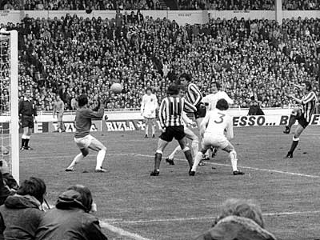
Ian Porterfield scores the winning goal

Thackeray Grove was a good place to grow up for places to play. At the end of the road was a field the size of a cricket pitch. This field led to a tree lined ‘beck’, that went all the way to Acklam High School, where Fiona and Dave went to school. “What’s a beck?” I hear you say. I’m not exactly sure, but if this ‘beck’ was anything to go by; It’s a tree lined overgrown ditch with water stagnating in the bottom, as it’s got nowhere to go. However this was our ‘beck’ and it even had its own name, ‘THE ARTY’. No idea where that name came from either.
One day while playing in ‘The Arty’ I came across a little furry black ball in a tree trunk. On further investigation I discovered it was a little kitten. This wasn’t the only kitten though, there were about ten abandoned in this tree. I ran home to get my brothers to come and help me rescue the kittens. We put them in two shoe boxes and took them all home. We gave them some milk and then decided to phone the RSPCA. I thought they were supposed to help animals, but they came, took one look at the kittens and said “Yeah, that’s OK we’ll get rid of them for you”. I was horrified; I grabbed the smallest kitten and ran to my room. I could hear the cries of the other kittens, as they were taken to their deaths. I was allowed to keep the little black kitten. I called her BECKY as I found her in the beck. I suppose I should’ve called her ARTY, but she’d have probably got ridiculed by her mates, when she got older.
We would bomb up and down the slopes in ‘The Arty’ on our CHOPPER bikes. Well that’s not strictly correct, I only had a CHIPPER (baby CHOPPER) bike, but I still thought I was the nuts. At the far end of ‘The Arty’ was a ‘Tarzy’. [A thick rope tied round a thick overhanging branch, with a big stick tied to the loose end, to act as a seat]. Now I do know where ‘Tarzy’ gets its name from. Tarzan, Lord of the Jungle. He would swing through the Jungle on a network of Tarzies, shouting “Ah, Ahhahah, Ahhahah” as he went. There are many theories as to exactly who Tarzan was, but it’s obvious to me that he was born and brought up in Middlesbrough. This ‘Tarzy’ in ‘The Arty’ was his legacy to the children of Linthorpe. He’s not the only famous person from Middlesbrough. The town’s most famous son is Captain James Cook. Cook was the man who discovered Australia and he was born in Marton. He’s even got his own Museum in Stewarts Park. Other famous people from Middlesbrough included two Icons of the 20th Century, Paul ‘Magic’ Daniels and Roy ‘Chubby’ Brown.
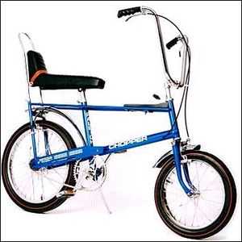

Raleigh Chopper Bicycle Mk1

As usual our holidays involved lots of miles, lots of camping and lots of rain. It was only me and Fiona (and Jenny the dog) that went on the holidays now. Charlie and Dave viewed our holidays, as you might say “While the Cat’s Away!” Our first trip was a long bank holiday weekend, at the end of May. This didn’t stop us circumnavigating Scotland in three days.

Day 1 – We drove to Edinburgh and visited the Castle and Princes Gardens. Then we did a bit of ‘Bridge Spotting’ at South Queensferry. Surprise, surprise it was the same two bridges as the last time we went there, The Forth Road Bridge and The Forth Railway Bridge. That’s not Forth as in The 4th Bridge, I’m sure that there were more than 3 bridges built before these two. It’s because they’re located in the Firth of Forth. Listen forget it. I could go on to explain that a ‘Firth’ is the arm of a river, the river estuary, but that would be disrespectful to any Scottish people reading this and too confusing for everyone else. Afterwards we drove to Perth (not the Australian one) and stayed in a B&B.
Day 2 – We drove via Glenshee to Braemar. On the way we stopped at Cairnwell, where Dad, Fiona and I went up the ski lift to the top. We went on to Ballater and had dinner at the Invercauld Arms Hotel. We camped in the V.W. by the River Dee.
Day 3 – We visited Balmoral Castle and walked round the grounds. The Royal Family was staying in the Castle that weekend, but didn’t have the manners to invite us in for a cup of tea. We drove home via Edinburgh and stopped to see the National Gallery. Dad was so predictable, Bridges, Art Galleries, Art Galleries, Bridges.
While in Balmoral the Engagement of Princess Anne and Lieut. Mark Phillips was announced. Old ‘Horse Face’ must’ve been up the duff! The wedding was set for the 14th November 1973. As it turned out she wasn’t, but I bet Prince Phillip still had a shotgun up Mark Phillips’ arse, “You will marry the ugly Princess, or you will both turn into green ogres after sundown”.
Our main summer holiday started on Sunday July 15th. Naughty, naughty, the school term didn’t end until Friday. Not that I was complaining, but I didn’t want Mum and Dad to go to prison just for the sake of a few days on rain soaked beaches in Cornwall. Anyway it was too late now, we’d driven to Essex to see Nanna then stay the night with the Bonner’s at Hole Farm.
The following day we set off for the West Country, me, Dad, Mum, Fiona and Jackie Bonner. We camped at Salcombe Regis in Devon, for the first two nights. Of course it rained for most of the time. On Wednesday we travelled to Cornwall and camped at the ‘Atlantic Coast Caravan Park’ at Gwithian. The next day we visited St. Ives and had a Fish & Chip lunch overlooking the harbour.
We spent the afternoon on Gwithian Sands. You didn’t get beaches like this near Middlesbrough, or anywhere else in this country, come to that. Fiona and Jackie went to the Palace Cinema to see the ‘Italian Job’. Probably with boys they probably met on the beach. It finally stopped raining on Saturday and was actually quite warm. So much so that Fiona and Jackie went sunbathing in the dunes, where they met a naked man! Poor bloke, someone must’ve pinched his trunks. Why else would a naked man be chatting to two 14- year old girls in secluded sand dunes? Oh, the innocence of youth! In the evening we visited Lands End. When I say we, I don’t mean we took the naked man with us. Anyway I think he was still looking for his trunks. When we left him he’d gone off into the dunes with two 14- year boys, obviously helping him search for that missing swimwear.
On another day we went to Penzance (didn’t see any Pirates) and in the afternoon Dad took us to St. Michaels Mount, but we were too late for a tour. We were too late, not because it was getting dark, it was because, St. Michaels Mount is out at sea and only accessible at low and mid tide by way of a causeway. It’s quite impressive though, this huge rock rising from the sea with a castle stuck on top. Historically, St Michael's Mount was a Cornish counterpart of Mont Saint Michel in Normandy, France.
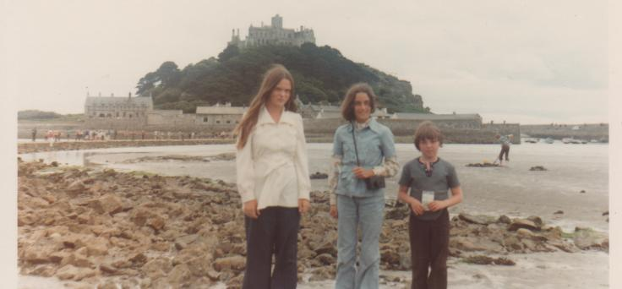
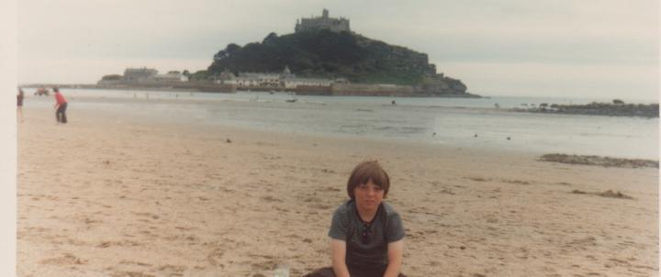

Fiona, Jackie Bonner and Me Me at St. Michael’s Mount

The following day we went to Newquay and did putting and trampolining. We then went to Truro and saw ‘Steptoe and Son Ride Again’ at the cinema. The last few days of the holiday were hot and sunny and we spent most of our time on the beach at Gwithian Rocks. Dad painted the view from the cliff top. After nearly two weeks away, we set off home (well not our home) at 11 am on Friday 27th July. We had a long day’s travelling via Dartmoor, Crediton, Taunton, arriving in Bristol at 8.30 pm.

On the Friday and Saturday after our holiday in Cornwall we stayed at Auntie Vi’s and Uncle Doug’s, in Bristol. Mum, Dad and Auntie Vi went to Llanelli to see Frank & Sally and Robert. Jackie was still staying with us after our holiday. She and Fiona took me to the Bristol 600 Exhibition. On the Sunday morning dad phoned home to check that Charlie and Dave had been behaving themselves while we’d been away! “Yeah Dad, it’s been pretty quiet here. Had a few friends round last night, couple of bottles of lager”. “How many friends?” “7 maybe 8, maybe 30!!” This ‘Bottle Party’ as Dad calls it, was what’s commonly known as a ‘Wild Party’. The full package, girls, gatecrashers, endless bottles and cans of ‘Kestral’ and ‘Skol’ lager, scratched furniture, vomit stains on the carpet and settee, angry neighbours. I couldn’t wait till we get home. They were in so much trouble.

Talking of bottles, the highlight of the week (well for me it was) was the arrival of the fizzy drinks man. When I was small we used to have Corona delivered by none other than the ‘Corona Man’. Every Saturday, I can still hear the glass bottles clinking together as he dropped the plastic crate on our doorstep. Our ‘Corona Man’ was from Russia, his name was DROPUSA BOTLAPOPOV. The bottles we had at the time were the old 25 oz bottles with a long neck and they later changed to 34.5 oz bottles (1 litre). The range of pop sold at the time was quite large with five different flavours in the litre bottle range which was orange, lemonade, cherryade, limeade and dandelion and burdock. A bottle of pop then cost 11½ pence plus deposit of 3 pence and a 1 penny delivery charge.

Remember I was telling you about my sister Fiona and how when she was 13, she changed her boyfriend every week. She was no different now she’d turned 14 years old, except she went for older men now. One day after school she went to Middlesbrough Town Centre to change a pair of shoes. While she was there she met a Greek 2nd Officer who took her to his ship, the ‘Minaoan Star’. Dad went to the docks to find her without success, but she came home by taxi unharmed. The following day the Greek sailor, Marcos, came to our house for the evening. I think most dads would’ve knocked his block off, but my dad isn’t like that. He was quite happy to listen to his stories of life on the high seas. On another occasion in September two youths from Birmingham knocked at the door, to see Fiona. They even stayed the night. Now how did Fiona meet two lads from Birmingham? My geography isn’t the greatest, but I knew Birmingham wasn’t anywhere near Middlesbrough. It’s not like we’d got internet chat rooms or mobile phones. Growing up in 1973 was like ‘Life on Mars.’ It turned out that she’d met them while on holiday in Cornwall and one of them, Ken Townsend was officially her boyfriend, well at least for that week. Ken and his mate Phil stayed for two nights before going on their merry way back to the Midlands. “Hey Ken, I think you’ll find that we’re considerably richer than yowel, alright mate, bye now”. Fiona joined the Avenue Methodist Youth club on Friday 26th October. On Sat. 27th October she went to the cinema with Martyn, who she’d met at the youth club, to see ‘Doctor Zhivago’. I wonder how much she remembered about that film.

Charlie (18) and Dave (17) wanted to be treated as adults, but the temptations of being that age and peer pressure would regularly let them down. The ‘Wild Party’ while we were on holiday was a prime example. Charlie especially, was a bit of a party animal. On Feb 17th he stayed out all night at a party, and then a few days later he went to a High School (Musical) Dance at Kirklevington Country Club. At the end of May he went on a coach trip with other Sixth formers to Scarborough. However instead of coming home on the coach they went to the ‘Cats Whisker’ night club in York and got home at 3 am. Dave wasn’t as bad, mainly because he was always playing golf, however Dad found out that he’d being smoking at the Golf Club and threatened to stop his pocket money.

We would often go to the cinema, especially during the summer holidays. On 14th August, Dave took me and my friend Andrew Brettle, to Stockton Odeon to see Walt Disney’s ‘Sword in the Stone’ and ‘The Incredible Journey’. I don’t know if you’ve seen ‘The Incredible Journey’, but it’s enough to make a grown man cry, not that Dave would admit it. The film is about three pets, Luath, a young Labrador, Bodger, an old English Bull Terrier and Tao, a Siamese cat. The Hunter family, that owns the pets, leaves them with a relative while they go away for a few days. The pets get homesick, escape and go on a journey to find their way home. Dodging death nearly every step of the way, but when Bodger gets attacked they have to slow down. Then Tao gets separated due to a fast flowing river. When the Hunter family return they’re devastated to learn that the animals have gone missing, but still have a party for the little boy, Peter.
Everyone is really sad, then suddenly out of the woods in the distance comes running Luath, then Tao. They’d found their way home to the delight of the family. This is the bit where the tears start to flow. Peter’s pet, Bodger, hasn’t made it, but just when all hope is lost, he appears and Peter runs across the field to embrace him (sorry I’ve just ruined the film for those who haven’t seen it). At this point Dave is sliding down in his seat, tears flowing down his cheeks. Andrew and I are also crying but that’s just about acceptable behaviour for 9 year olds. Dave tries to bribe us with ice cream, popcorn and hot dogs, to keep quiet about his embarrassing episode in the cinema.

Sunday December 9th was a busy day for the family. David, Stephen Bilton, Fiona and Martyn French went to a ‘Black Sabbath’ concert in Newcastle. Earlier in the day dad had cut my hair as I was going to a party. Thanks dad, a basin hair cut was really going to help with my street cred. The birthday party was for my best friend, Simon Berry, who was 10 years old. Simon lived in Westwood Avenue, which was not far from Thackeray Grove, where we lived. Simon had two brothers, one older and one younger. His older brother was called Charles, but more commonly known as Chas and his younger brother was called Jonathan. Simon’s dad (Alan) had the best job in the world, not that we realised that. He was the Sports Editor of the Middlesbrough Evening Gazette newspaper. We would benefit from this when we got older.

Vernon Henry Baldwin 23rdJanuary 1949 – 14thDecember 1973 – My Uncle Vernon died on Friday 14th December, two and a half years after first being diagnosed with a brain tumour. He was only 24 years old. Vernon was my dad’s half brother (son of my Grandad and Auntie Barbara, who also had another son Julian). It was a tragic loss, of someone so young and intelligent. Vernon had been studying for a University degree in Electronics at Canterbury. He was very clever, even designing and flying his own control-line model aircraft. He was also very keen on Amateur Radio, more commonly known as a ‘Radio Ham’. Grandad had all manner of radio equipment in his workshop and Vernon would spend hours in there, contacting other people with similar equipment. It had been a very difficult time for Grandad and Barbara, with Vernon in and out of hospital and prone to violent rages and difficult behaviour, but they stayed strong throughout and gave him the best care possible. On the 19th December we all travelled to Bristol. Dad, Mum, Charlie and Dave went to Vernon’s Funeral. He was cremated at Canford Lane crematorium.

We stayed in Bristol for Christmas, having Christmas Day at Auntie Vi’s and Uncle Doug’s in Westbury-on-Trym. On Christmas Day I watched TV all day. In the 70’s all the best programmes were saved up until Christmas. The Christmas Day schedule on BBC1 was as follows:-

The Black and White Minstrels at 1.30pm were succeeded by Top of the Pops '73, hosted by Tony Blackburn and Noel Edmonds. Then after the Queen came Billy Smart's Circus, the panto at 4.20pm (Robin Hood, with Anita Harris in the title role), The Generation Game, Mike Yarwood at 7.05pm and Morecambe and Wise at 7.35pm with their obligatory remarkable supporting cast: Vanessa Redgrave, Yehudi Menuin, Rudolf Nureyev, Laurence Olivier and The New Seekers. For once there was a good film to follow: The Odd Couple, running through to 10.30pm. Time for bed I think! Other classic programmes on over the festive period included, Some Mothers do ave ‘em, following the antics of Frank Spencer, The Two Ronnies and the Basil Brush Show.

1973 Facts & Figures
Jan 1st - Britain, Ireland and Denmark become members of the EEC.
Jan 23rd – A peace treaty is signed in Paris, to bring to an end the Vietnam War.
Feb 14th – British boxer Joe Bugner fought the fight of his life, losing on points to Muhammad Ali in Las Vegas.
Mar 3rd - One person was killed and 250 injured, when two IRA bombs exploded in Central London.
April 1st – VAT is introduced into the UK.
April 4th – The World Trade Center was officially opened in New York City.
April 30th - Four of President Nixon’s top aides resigned over the Watergate scandal.
May 5th – Sunderland of the 2nd division won the FA Cup, beating Leeds United 1 – 0.
Sept 7th – F1 Racing Driver, Jackie Stewart, announces his retirement after clinching his 3rd World Championship.
Oct 20th – The Sydney Opera House is opened by Queen Elizabeth II.
Nov 14th – Princess Anne married Captain Mark Phillips at Westminster Abbey.
Dec 31st – Due to coal shortages, the electricity consumption reduction measure, the Three Day Week, came into force.

Top Films of 1973 – The Exorcist, the Sting, American Graffiti and Live and Let Die (James Bond).
Pink Floyd’s Dark Side of the Moon, one of rock’s landmark albums is released. Also Tubular Bells by Mike Oldfield.

Deaths
Jan 22nd – Lyndon Baines Johnson “LBJ”, 36th President of the USA, died aged 64.
Jan 26th – Edward G Robinson, American Actor, died aged 79.
Mar 26th – Noel Coward, English Composer and Playwright, died aged 73.
April 8th – Pablo Diego José Francisco de Paula Juan Nepomuceno María de los Remedios Cipriano de la Santísima Trinidad Martyr Patricio Clito Ruiz y Picasso (Pablo Picasso), Spanish Artist, died aged 91.
May 18th – Jeannette Rankin, 1st US Congresswoman, died aged 92.
July 7th – Veronica Lake, American Actress, died aged 50.
July 20th - Bruce Lee, Chinese American Martial Artist, died aged 32.
July 29th – Roger Williamson, British F1 driver, died in a car fire in the 1973 Dutch Grand Prix, only his 2nd F1 race, aged 25.
Sept 2nd – J .R .R. Tolkien, British Author of ‘Lord of the Rings’, died aged 81.
Sept 15th – King Gustav VI Adolf of Sweden died aged 91.
Dec 20th – Bobby Darin, American Singer died aged 37.

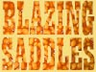
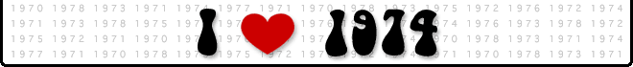
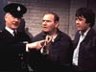
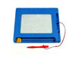
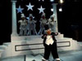


Porridge the Wombles Blazing Saddles Magna Doodle McDonalds

My brother David didn’t have a very good start to the New Year He was working at Woolco on New Years’ Eve and all the lads working that night thought it would be a good idea to dare each other to try and smuggle out a bottle of Whisky in their jacket. However he got caught red handed and the Police were called. On the 4th January, Dad went to see Mr. Fleming the manager of Woolco, to apologise for David’s actions. In the evening David was charged at Thornaby Police Station with theft by Det. Con. Cole. Then he went to Middlesbrough Police HQ to be fingerprinted and photographed. On the 7th January Dad went with David to the Middlesbrough Law Courts. The magistrates gave him Life with no parole, only joking; they gave him a Conditional Discharge -basically a slap on the wrist.

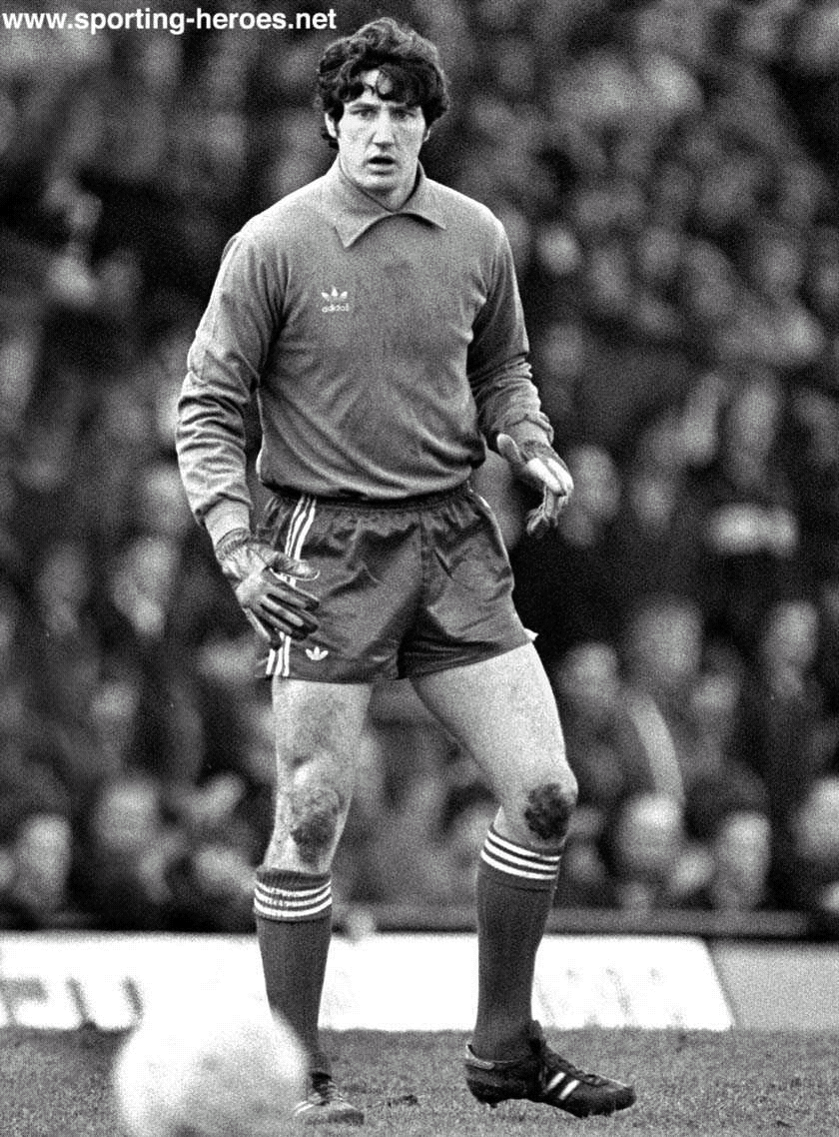
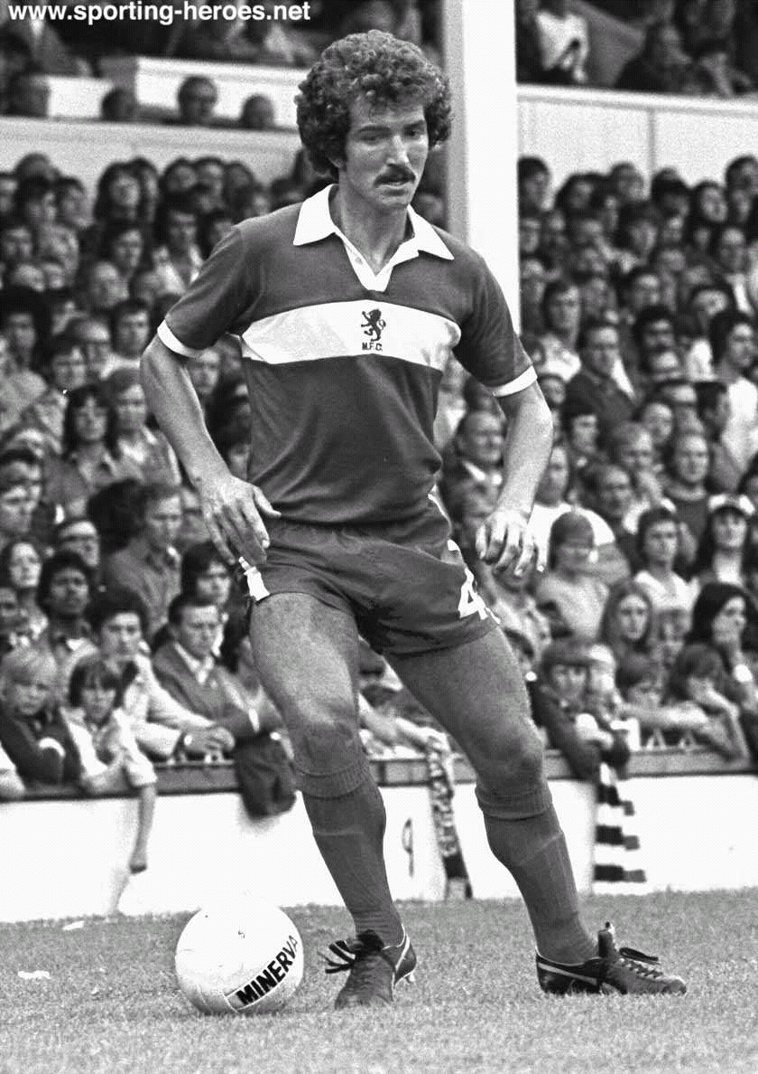
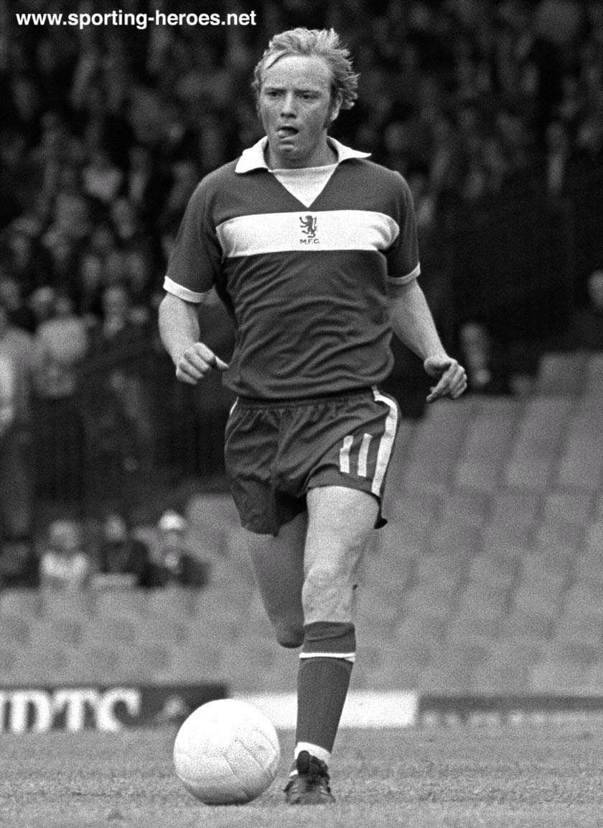
February 23rd 1974 was a significant day in the life of Alister James Baldwin; it was the day I went to my first ‘Boro game. Simon Berry’s dad took me and Simon to Ayresome Park to see Middlesbrough play Swindon Town. We arrived in good time for kick off, purchased a programme outside the ground and made our way to the Turnstile. We entered the ground and climbed the steps that led to the section of the ground affectionately known as ‘The Boys End’. There was nothing classy about this place, if you looked down while climbing the steps you could see blokes taking a pee against a wall with a trough at the bottom, this was the Gents Toilet. ‘The Boys End’ was in one corner of the ground and was just a mass of concrete terracing, with concrete barriers. I realised that for future games I was going to have to take something to stand on, as I couldn’t see a thing, but the atmosphere was electric. From this moment onwards I would eat, sleep and drink football. The sad thing is I can still remember that team line up as if it was only yesterday.

Jim Platt Graeme Souness David Armstrong

1. Jim Platt 2. John Craggs 3. Frank Spraggon 4. Graeme Souness 5. Stuart Boam 6. Willie Maddren 7. Bobby Murdoch 8. David Mills 9. John Hickton 10. Alan Foggon 11. David Armstrong

The attendance was 23,194 and I was one of them. Boro won the game 2 – 1 with goals from John Hickton and Alan Foggon. This was the 2nd victory in a winning streak that was to last 9 games, which saw Boro run away with the 2nd Division title by 15 points and that was when it was only 2 points for a win. They even thrashed Sheffield Wednesday 8 – 0 (Souness Hat-trick) for good measure, at the end of the season. The mastermind behind this team was manager, Jack Charlton. He had only been appointed in 1973 and it was his first managerial post. Apart from his success on the park, one significant change he made was to introduce the White Band across the Red shirt. To fans like me, that is the only true Boro shirt. At the end of the season David and I went to see the team’s open top bus procession through town, finishing at the Evening Gazette offices.

Back in the Seventies Football was simple:-
There were 4 Divisions. - Division 1, Division 2, Division 3 and (go on, I’ll let you guess the last one)? None of this Coca Cola Championship, League 1, and League 2 rubbish. Surely if you win the Championship, you’re the best team in the country. If you play in League 1, you’re playing in the top Division.
None of this squad rotation malarkey. If you weren’t in the 1st XI you didn’t get a game.
There was only one substitute allowed.
Players shirts were numbered from 1 – 11 and No. 12 for the sub. No shirt sponsor, no name on the shirt.
Players were allowed to tackle from behind; punch-ups were common place, no bookings for taking your shirt off (not that you could get those long sleeved cotton shirts off, especially in the rain).
No foreign players on ridiculous wages. The most foreign Boro got were, Jim Platt (Ballymena, Northern Ireland), Graeme Souness (Edinburgh, Scotland), and Bobby Murdoch (Glasgow, Scotland).

Another trait of a 10-year old football fanatic was an unhealthy obsession with Subbuteo. Richard English, a friend of mine from Green Lane School had all the latest stuff and we would often spend hours round his house playing Subbuteo. Richard lived in Emerson Avenue, which was just round the corner from our house. He played Subbuteo so much that he’d worn out the knees in all his jeans. The reason for this was that Richard didn’t have a table big enough for the pitch, so we had to play on the floor.
To those of you who can only ever remember playing computerised football games, this was the king of football games. Playing Subbuteo involved a lot of skill in flicking the playing pieces, which stood on weighted bases, across the tabletop mat towards the ball, which was oversized and stood nearly as high as the players.
There were hundreds of team kits and accessories. Subbuteo had several team designs, all for real teams. While some team colours could naturally be used to represent different teams, such as reference 001, which could be used as many teams, including Arsenal, Manchester United and Nottingham Forest. The most popular team to have was Brazil (or Norwich City). There were also many additional accessories, such as new balls and goals, special figures for free kicks and throw-ins, stands and crowd, streakers and policemen, floodlights, and TV cameras. The most common injury for a Subbuteo player was the knee injury. That’s not their knee; it’s our knee accidentally crushing a player (mainly near the corner flag) as we moved round the pitch. However unlike real footballers, having both legs completely snapped off, was only a minor injury. A bit of Airfix model glue and the player would be available again for selection within a couple of hours.
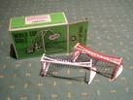
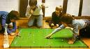
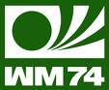
The rules of Subbuteo table football were an attempt to correspond closely with the game itself. However the simplifications involved in some ways complicated things further. Players maintained possession as long as the figure they flicked made contact with the ball and the ball didn’t subsequently hit an opposing figure, although the same figure couldn’t be used for more than three consecutive flicks. Shots at goal could be taken once the ball was over the 'shooting line', a line parallel to and equidistant between the goal line and half-way line. Goalkeeper figures were attached to a rod that fitted underneath the back of the goal. The offside law was in effect, but only pertaining to figures that were forward of the opposing team's shooting line (as opposed to the half-way line, as in actual football).
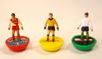
Subbuteo Players 1974 World Cup Goals Subbuteo 70’s style 1974 World Cup Logo

Mum had been unwell for some time. She’d been suffering from irregular blood sugar level (Diabetes) and after seeing Doctor Strachan on Feb 21st it was decided that mum would have to go on insulin. On March 4th mum went into Ward A of the Carter Bequest Hospital, to start her life on insulin. Mum had to spend 10 days in hospital being treated by Dr.Strachan. Mum would have to have an Insulin injection everyday for the rest of her life.
Some more French Students came to stay with us on July 7th, Sandrine Hervieux from Lapalud and Eric Munch from Pierrelatte. [I wasn’t there when they arrived as I was busy watching the World Cup Final between West Germany and Holland (2 – 1), at Simons house]. David had been to stay with Eric earlier in the year and this was the return visit.
Why was it that French students could always speak English, when we were rubbish at speaking French? We learned French for 11 years at school, but it’s as if someone completely wipes the language learning part of your brain on your last day school. They leave you with some random words and phrases, such as:-
Merci Beaucoup, Si vous plait, Petit Dejeuner, L’escargot, Je ne sais quoi, Ferme la Porte, Je ne regrette rien, Boulangerie.
The first thing they taught us at school was how to ask someone their name and how to reply. Comment t’appelles – tu? (Trans. What are you called?) Je m’appelle Alister. (I am called Alister). My answer should be just, Alister (What’s your name? Alister), but in French why use one word when you can use four or five.
Also we weren’t allowed to use our real (English sounding) names. So I had to be Alain, Peter would be Pierre, John would become Jean (That’s pronounced Jon, not like your Auntie Jean) and Michael would be called Michel (Girls name, Girls name!!). I wanted to be called Marcel, as it sounded good and it rhymed.
Je m’appelle …… Marcel.

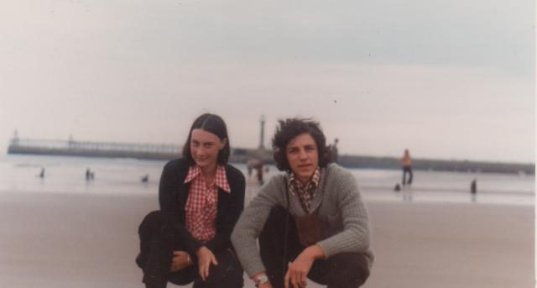
Sandrine and Eric
We really knew how to show these French kids a good time. David and Fiona took them to Lackenby Steel Works, to see steel being made, just what they had planned on their first trip to England. We did take them on more interesting days out. We went to Whitby one day, however the best day out was probably to York. We went to the Castle Museum, Clifford Tower, had a trip up the River Ouse and went to York Minster. We even threw a party at our house for all the French kids staying with their school friends. The school also took them all on a coach trip to Scarborough and Helmsley Castle. They didn’t do too badly out of us. Add to this, bowling in Albert Park, three trips to the Cinema, day trip to Edinburgh, skating and swimming. Eric and Sandrine even swam in the sea at Marsden Bay on the Durham coast, not quite the Mediterranean Sea. On her last night with us Sandrine phoned her mother in France, she was on the phone for approx. 12 mins 08 Secs, not that anyone was counting. On their last day David took Eric to the Cleveland County Show. Eric and Sandrine left with the other French students at 11.35pm – back to France. Au Revoir, Bon Voyage, Bon Appétit,
You’re probably bored to tears reading about all our holidays, but let me quickly tell you about our half term trip to Scotland. Yes that’s right, Scotland again. We must’ve been up for the Scottish Tourist Board, ‘Visitors of the Decade Award’. As usual we drove miles and of course we had to take in a bridge crossing or on this occasion two bridges. We went over the Forth Road Bridge (done it, bought the T-Shirt), then we crossed a new bridge. However dad had to wait for the sun to shine, so that he could say “We crossed the Tay Bridge and the ‘Silvery Tay’ was silvery in the sunshine, at Dundee”. We finally arrived in Aberdeen, but we had to wait until it was dark, so that dad could say,

“The Northern Lights of old Aberdeen, Mean home sweet home to me, the Northern Lights of old Aberdeen, Are what I long to see, I’ve been a wanderer all of my life, And many a sight I've seen, God speed the day when l' m on my way, To my home in Aberdeen”.


The ‘Northern Lights’ or ‘Aurora Borealis’

The ‘Northern Lights’ or ‘Aurora Borealis’ to give them their correct name, are natural coloured light displays in the sky, usually observed at night, particularly in the polar zone. Unfortunately it was pouring down with rain when we got to Aberdeen, so we saw nothing.
We spent a couple of days in Aberdeen. We went to an amusement park and visited the Hazelhead park Zoo and maze. After leaving Aberdeen we headed to Inverness. On the way we stopped at Tomintoul Distillery, where dad bought a 100% proof, bottle of whisky. We camped at Bught Park in Inverness. The next day we visited Urquhart Castle on Loch Ness, then drove via Beauly to the Black Isle. We returned to Inverness on the Kessock Ferry. While on the ferry you could see dad thinking, “A bridge would fit in that gap, just nicely”. They could call it ‘The Kessock Bridge that put the ferry out of business’. Dad was definitely thinking bridge, as the next day, while mum took Fiona and me on a boat trip down the Caledonian Canal to Loch Ness, dad returned to the Black Isle. He climbed the hill above Rosemarkie, to photograph the scene. Our week long holiday ended with a 300 mile drive home from Inverness, via Aviemore, Pitlochry, Perth and Edinburgh. Dad visited the Royal Scottish Academy, summer exhibition and I played putting in Princes Gardens.
When we were home dad did a painting of what the Kessock Bridge might look like (see below). Ok, that’s not strictly true. Dad did do the painting. It is Kessock Bridge, but it was painted in 1982 (see 1979 – 1982 The Inverness years. Dad was the R.E. (Resident Engineer) on the bridge and his painting was used as the front cover of the bridge opening, souvenir programme).

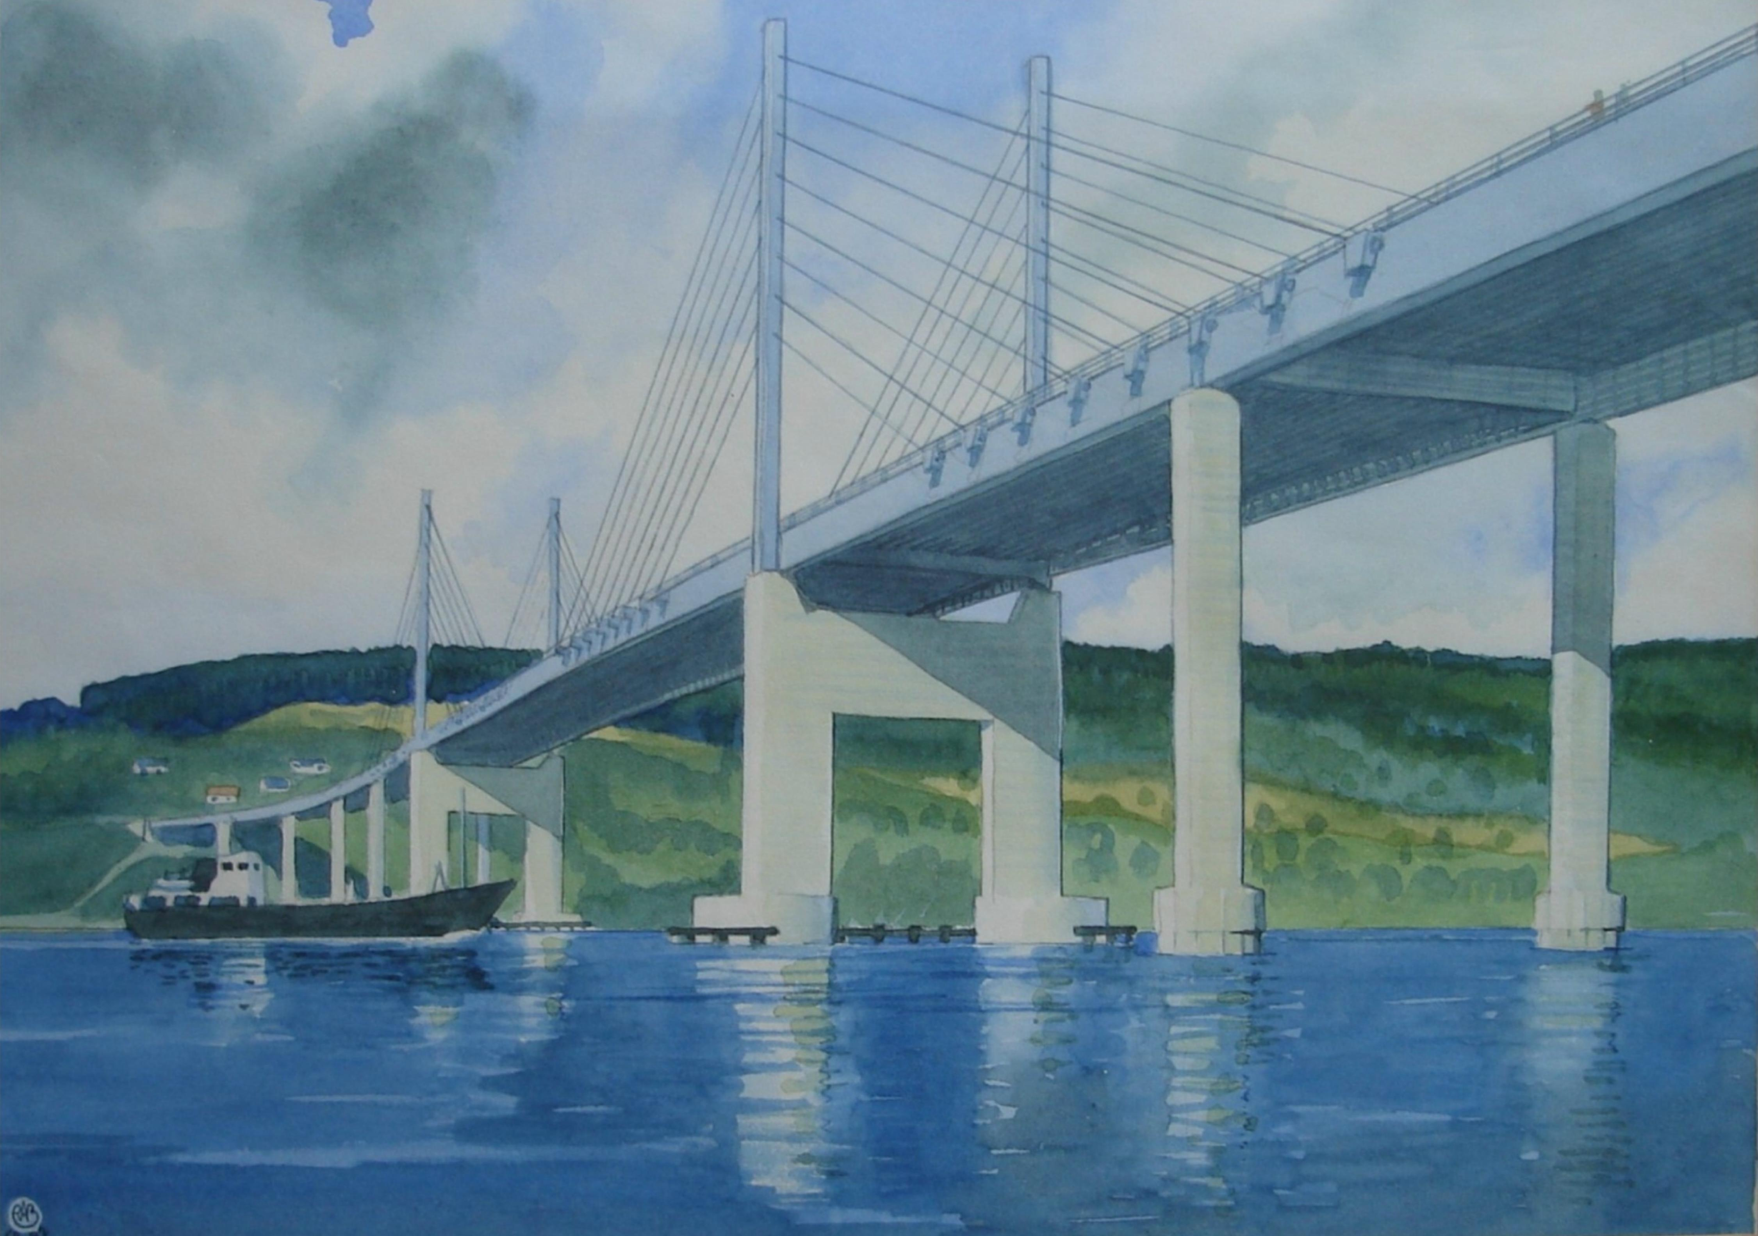

I would often go swimming with my friends. We would usually go to either the modern swimming baths at Berwick Hills or Eston or the old swimming baths in Middlesbrough town centre. On March 6th Simons mum took us to the Old Middlesbrough baths, which is where we also used to go with school. The ‘Old Baths’ were as the name might suggest, old. They had changing cubicles along both sides, no slides, Jacuzzi or wave pool. The Deep End was about 60ft deep and the Shallow End about 30ft deep, God help you if you couldn’t swim. At school swimming lessons, you would have to do certain things to achieve your swimming proficiency badges. Most of these made sense, swim from one end of the pool to the other without drowning, swim 200 metres underwater without breathing and tread water for 15 hours. However one task was slightly bizarre, dive into the deep end, in your pyjamas to rescue a black brick. It’s hard to imagine a scenario where you’d find yourself in deep water wearing your pyjamas. - Ok, let’s suppose you’re on board Titanic II and it’s going down after hitting an iceberg in Middlesbrough docks. I’m pretty damn sure I wouldn’t be looking round for a black brick to throw overboard with the intention of diving in to find it. School swimming lessons would’ve been much more practical, practising jumping in life-boats with your pyjamas on.
My brother Charlie must’ve been one of the unluckiest people I knew. He was studying for ‘A’ Levels, but busy applying to Universities and for job interviews. Let’s go back a year to begin his sorry story.
Feb 28th 1973 - Charlie had arranged an interview at Huddersfield University, but couldn’t go because of a one-day railway strike.
March 14th – Had an interview with Midland Bank in Newcastle, didn’t get the job.
April 16th – Got a part-time job at Woolco, lasted a week.
July 10th – Asked Monk’s for a Chainman’s job on Teesside Parkway, didn’t get the job.
August 13th – Went to Manchester for job interview as Trainee Manager at Sainsbury’s.
August 14th – Did start work (7.30am) with J.S. Raine & Co. Industrial cleaners, spent 10hrs cleaning greasy machinery.
Sept 6th – Had an interview and medical at Sainsbury’s in London, didn’t get the job.
Sept 7th – Fed up trying to find gainful employment, Charlie turned his attention to Further Education (F.E.). He wrote to Teesside Polytechnic about a Business Studies course.
Sept 12th – Changed his mind about F.E. and went for an interview with Faithfull and Gould for a job as a trainee quantity surveyor in Stockton, didn’t get the job.
Sept 13th – Dad arranged an interview with Mr. McBride of P.E.R. (Professional & Executive Register).
Sept 17th – Interview with P.E.R., didn’t get the job. In the afternoon he re-applied to Teesside Poly for a Business Studies Course.
Sept 24th – Did eventually start at Teesside Polytechnic.
April 18th 1974 – Did a labouring job at Wainstone’s Hotel.
April 25th – Had a interview at British Steel Corporation (B.S.C)
June 11th – Received a letter from B.S.C., didn’t get the job but received an invite to an interview with W.H.Smith & Son.
July 4th – Went for an interview with W.H.Smith's in Bradford, didn’t get the job.
July 5th – Dad went to see Mr. Bridger, Head of Business Studies at Teesside Polytechnic. It transpires that there may not be enough students’ for a 2nd Year of the course.
July 27th – Charlie was unsuccessful getting a job as a Car Park Attendant at the Teesside Eisteddfod. Things are now getting desperate, when you couldn’t even get a job as a Car Park attendant.
August 12th – Did start work as a Chainman on a 10-Storey building in Billingham, but passed out on his first day, with an Insulin reaction. He recovered in the Health Centre, but was still sacked.
August 14th – Started work again at J.S. Raine & Co. Industrial cleaners, off sick second day after being sick from the water at work. However, he did stay in this job until September 13th.
August 28th – Fire broke out on the ‘Afric Star’ in Smith’s Dock. Charlie was on the deck at the time; he had to get off quick.
Sept 22nd – Moved to Liverpool to complete the 2nd year of his Business Studies course at Liverpool Polytechnic.

My other brother Dave, meanwhile was about to take a completely different career path. Maybe it had something to do with his brush with the law at New Year; he decided he wanted to join the Army. On June 27th he went to Minley Manor, Camberley, for an interview with the Royal Engineers. After leaving school for good on July 19th he went to the Army Recruiting Office on the 29th, where he passed a medical. He enlisted on Aug 5th and then joined the Army proper on Aug 13th in Sutton Coldfield. A few days later he joined up with the Royal Engineers in Farnborough. His first leave of 14 days was less than a week after joining the Army! I think I’ll sign up, sounds like a doddle. Dad went to meet Dave at Darlington at 3.00am. However he was sound asleep on the train, but dad woke him up just in time. During his leave it was his 18th Birthday on 26th August. Dave returned to camp at Farnborough on Sep 1st. As part of his training he went on a 5 day adventure course in Snowdonia. Despite seeming to be enjoying Army life, Dave phoned home on Nov 20th to say he wanted to quit. Dad sent him £20 and he paid himself out of the Army. He arrived home, discharged from the Army, on November 29th. So it came as a bit of a surprise when he received a posting to Germany, just before Christmas. Anyway, I thought the war with Germany was over nearly 30 years ago!
My sister Fiona had also landed herself a part-time job, working at Shipman’s baker’s shop in Acklam. She must’ve made a good impression, as she was given a 25% pay rise, to the massive amount of 30p/hour. Fiona had a new boyfriend, Stephen. He took her to a ‘David Essex’ concert in Stockton and the following week to the cinema to see the latest James Bond film, ‘The Man with the Golden Gun’. However, just when things looked like they were going great, on December 14th Stephen came over from Thornaby to tell Fiona they were finished – she stood him up on a date the night before. He obviously didn’t match up to Fiona’s high standard of boyfriend material.
Dad somehow found time for hobbies, what with being the country’s top engineer and having four children to support. He was always brewing something in those big bottles he had. Lager, Beer and various flavours of wine, basically whatever he could get his hands on, Orange, Apple, Banana, Elderberry, Nettles to name but a few. But his real passion was painting. He enrolled in the Art Class at the Art College, which was literally just across the road. Now don’t get me wrong, Dad was a brilliant artist, but all those paintings of bowls of fruit and vases of flowers were just a cover for what he really went to Art Class for! Nude Models!! We’re talking nothing on, starkers. One night they had two models, one ‘Angie’ was on her last week and the other one ‘Yvonne’ on her first. Dad enrolled for the summer term in the ‘Life and Portrait class’ (that’s the arty way of saying ‘Naked Women’). On May 16th they had four nude models; I seem to remember he ran out of paint that night.
On February 13th Mum and Dad went to Green Lane School to see my work and talk to my teacher Mrs Widdowfield. I was doing OK and enjoyed going to school, there was always something going on and lots of school trips. I was showing signs of being creative, having made a butterfly kite and elephant collage. On June 10th mum came on our school trip. It was a walk from Port Mulgrave along the beach to Staithes. There was quite a bit of climbing involved over and around slippery Rock Pools and beach type rock formations. I bet Mum wished she’d signed up for a less dangerous school activity, like making cakes for the school fete. A couple of days later we went on another trip. This one was courtesy of the Baldwin family. I went with Mr. Jardine, Mrs Widdowfield and nine other pupils to visit Dad’s bridge site. Dad showed us around and we all got to wear a hard hat, in case a steel girder fell on our head. Like a hard hat would make much difference. “Ouch, that 1,000 ton steel girder really hurt. It would’ve been a lot worse though, if it weren’t for that hard hat”.
Dad was a bit of a local celebrity, not A-list, more Q-list or R-list. Basically he’d been on BBC’s ‘Look North’ a couple of times talking about the bridge they were constructing.
In September ’74 I started my last year at Green Lane Primary School and had a new teacher, Mrs Ann Wigham. She seemed OK, a bit bossy and she expected you to pay attention, something I wasn’t good at. She did teach us to play hockey though, sometimes when we should’ve been studying. The school trips kept on coming as well. On October 1st we went on a school coach trip round Teesside industry on both sides of the river. At Seal Sands we saw a flamingo. It probably wasn’t, more likely it was a seagull that had mutated due to being exposed to all the chemicals and pollution in the air. On Nov 2nd Mrs. Wigham took us on a school hike from Guisborough (where she lived) to High Cliff in the Cleveland hills. Again this was in no small part achievable thanks to Dad and his Land Rover, transporting all these kids over to Guisborough.
We continued to have an open house, with visitors coming and going and staying all the time. Thinking back where did they all stay? Charlie and Dave shared a room, Fiona had her room and I had a box (room). Maybe that’s what our mysterious front room was for. It was a real 70’s thing to have a room for best, what you oldies would call a parlour. We had this huge lounge, with a nice 3 piece suite, coffee table, corner unit with finest crystal glasses and a record player (Not that we had many records, we had a couple of Top of the Pops LP’s, Joseph and his Technicolor Dream coat, Tijuana Brass and Showaddywaddy). We even had new gold colour vinyl wallpaper. However despite having all this we didn’t use this room as the main living area, we all crammed into the back room. We had a brown sofa that looked like it was taken from the set of the new ITV sitcom ‘Rising Damp’, brown carpet and brown & white flowery curtains. One good thing in the room was a serving hatch direct to the kitchen. You didn’t even need to leave the room to drop off your washing up.
Anyway I digressed from telling you about our visitors. In February Barry & Muriel came for the weekend, with Jackie & Penny. At Easter, Auntie Vi & Uncle Doug came to stay. In August Uncle Stuart & Auntie Shirley stayed for a couple of days, before heading off to Edinburgh. A few days later dad’s cousin Andy Beaven, wife Kathleen and their three girls stayed the night. Also in August another of dad’s Cousin’s, Roger Tomlinson (well sort of cousin, its difficult knowing who’s who in dad’s family. Roger is Auntie Barbara’s nephew; Auntie Barbara is dad’s stepmother. So Roger is a sort of step half cousin once removed) came to visit with his fiancée Rosemary. Roger & Rosemary actually got married a few weeks later on August 24th. In September we had visitors from Australia, Uncle Phil, Auntie Renée and their daughter Andrea. They stayed for a week. Then Auntie Vi & Uncle Doug were back for Christmas.

1974 Facts & Figures

Feb 14th – Nobel Prize winning Author Alexander Solzhenitsyn is expelled from the Soviet Union.
Feb 28th – The General Election ends in an almost dead heat. Harold Wilson becomes Prime Minister again.
Mar 3rd – A Turkish Airlines DC-10 travelling from Paris to London crashes in a wood near Paris, killing all 346 on board.
Mar 20th – Princess Anne was shot at in a failed kidnap.
Apr 6th – Abba, singing Waterloo, won the Eurovision Song Contest, held in Brighton.
May 17th – Thirty Three people died and over 300 injured after three car bombs in Dublin and one in Monaghan.
May 19th - Valery Giscard d’Estaing was elected President of France with 51% of the vote.
June 1st – An explosion at a chemical plant in Flixborough kills 28 people.
Aug 8th – President Richard Nixon announced his resignation, in light of the Watergate scandal.
Aug 9th - Gerald Ford was sworn in as the new President of the United States.
Nov 12th - Richard John Bingham ‘Lord Lucan’ was being sought by Police after the murder of his nanny, Sandra Rivett.
Nov 21st – IRA terrorists killed 17 people by blowing up two pubs in Birmingham.
Dec 31st – Soaring inflation has Britain reeling. Cost of living is up 20% and a gallon of 4 – star petrol cost 42p in January, now costs 72p.

McDonalds opened its first restaurant in London, in 1974.
Hits of 1974, Billy don’t be a hero, Seasons in the sun, Tiger feet, Kung Fu Fighting, Waterloo, the Joker.
New sitcoms in 1974, Rising Damp and Porridge.

The 1974 FA Charity Shield was between 1973–74, champions Leeds United and 1974 FA Cup Final winners Liverpool. Bill Shankly led Liverpool out onto the pitch for the last time; he had retired in May 1974 to be replaced by Bob Paisley. The match will be forever remembered by the display of violence of Billy Bremner and Kevin Keegan who were dismissed after the hour for trading punches in true playground style. Both players felt they had been harshly treated and for no good reason took off their shirts, flinging them on to the Wembley track as they left the pitch. The FA fined both players £500 and banned them until September meaning they would miss 11 matches. It was the first Charity Shield ever to be shown on television.

Deaths
Jan 31st – Samuel Goldwyn, Polish born film producer, died aged 94.
Apr 2nd – Georges Pompidou, President of France, died aged 62.
Apr 24th – Bud Abbott, American actor, straight man of comedy duo Abbott & Costello, died aged 78.
May 24th – Duke Ellington, US jazz pianist and bandleader, died aged 75.
July 1st – Juan Domingo Perón, 3 times President of Argentina, died aged 78.
Aug 26th – Charles Lindbergh, US aviator, died aged 72.
Oct 13th – Ed Sullivan, American TV Presenter, The Ed Sullivan Show, died aged 72.
Dec 26th – Jack Benny, US Comedian, died aged 80.

